Kansas City Area Teachers of Mathematics
2013 KCATM Math Competition

NUMBERS AND OPERATIONS
GRADE 4

NO CALCULATOR

INSTRUCTIONS – You MAY write on this test!

• Do not open this booklet until instructed to do so.

• Time limit: 15 minutes

• You may NOT use calculators on this test.

• Some multiple-choice questions do NOT have the correct answer as one of the choices. On those questions, the response is: E. None of the above
Example: 3 + 4 = A. 4 B. 5 C. 6 D. 8 E. None of the above

• If a division problem has a remainder (for instance 21 ÷ 5 = ??), the answer is in this form: 4 r 1

• Simplify ALL fractions. Fractions must be expressed in lowest terms.

• All answers that are improper fractions are written as mixed numerals or whole numbers.
Examples: should be written as 2
should be written as

Student Name ____________________________ Student Number ______________

School __________________________________

- Sophia is 9 years old. Her uncle is 4 times Sophia’s age. How old is Sophia’s uncle?
- 32 B. 34 C. 36 D. 45 E. None of the above

- Alden’s family traveled 194 miles the first day of vacation, 173 miles the second day,
and 98 miles the third day. Approximately how far did they travel in those 3 days?
- 475 mi. B. 430 mi. C. 500 mi. D. 400 mi. E. None of the above

- An adult brown pelican eats three times as many fish as a young brown pelican. If one adult brown pelican eats 420 fish, how much would 2 small pelicans eat?
- 140 fish B. 240 fish C. 180 fish D. 280 fish E. None of the above

- Ethan is 8 years old. His grandfather is eight times his age. How old is his grandfather?
A. 56 yrs. B. 58 yrs. C. 64 yrs. D.72 yrs. old E. None of the above

- Your class wants to recycle 500 aluminum cans this week to raise money for a family in your school. The first day your class collected 5 cases of 24 cans, the second day 90 cans were collected. How many more cans do they have to collect on the next three days to meet their goal?

A. 290 cans B. 300 cans C. 310 cans D. 280 cans E. None of the above

- Which number is represented by the expanded form: Four hundred fifty-seven thousand?

A. 400,570 B. 450,700 C. 400,057 D. 457,000 E. None of the above

- Five tens plus six tens is equal to which number?
A. 56 B. 110 C. 560 D. 65 E. None of the above

- Which expression is NOT equal in value to 8 x 549?

A. 8 x 500 + 8 x 40 + 8 x 9 B. 4,000 + 320 + 72
C. 8(500 + 40 + 9) D. 8 x 500 + 8 x 49 E. None of the above

- Which fraction is equivalent to $\frac{2}{5}$?
A. $\frac{6}{\text{10}}$ B. $\frac{6}{\text{15}}$ C. $\frac{8}{\text{15}}$ D. $\frac{\text{10}}{\text{20}}$ E. None of the above

- Where is $\frac{4}{3}$correctly placed on the number line?
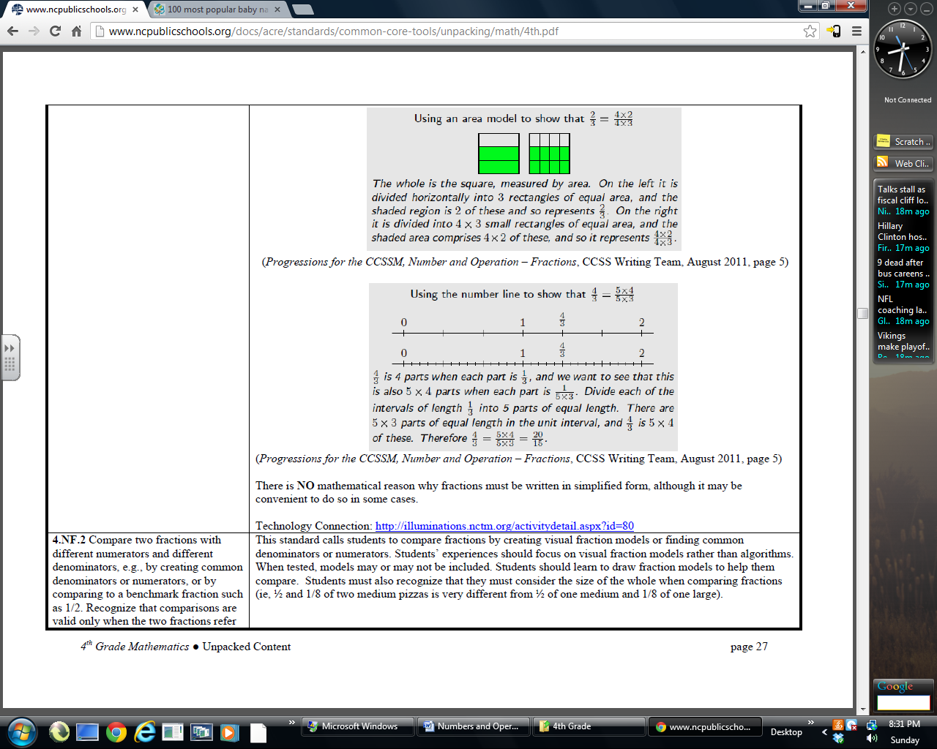
$$\frac{4}{3}$$
A.
$$\frac{4}{3}$$

B.
$$\frac{4}{3}$$
C.

D. E. None of the above

- Which diagram does NOT show the value of $\frac{2}{3}$ shaded in?

C. | D. | E. None of the above

- Which of the following statements is NOT represented by the following number line?
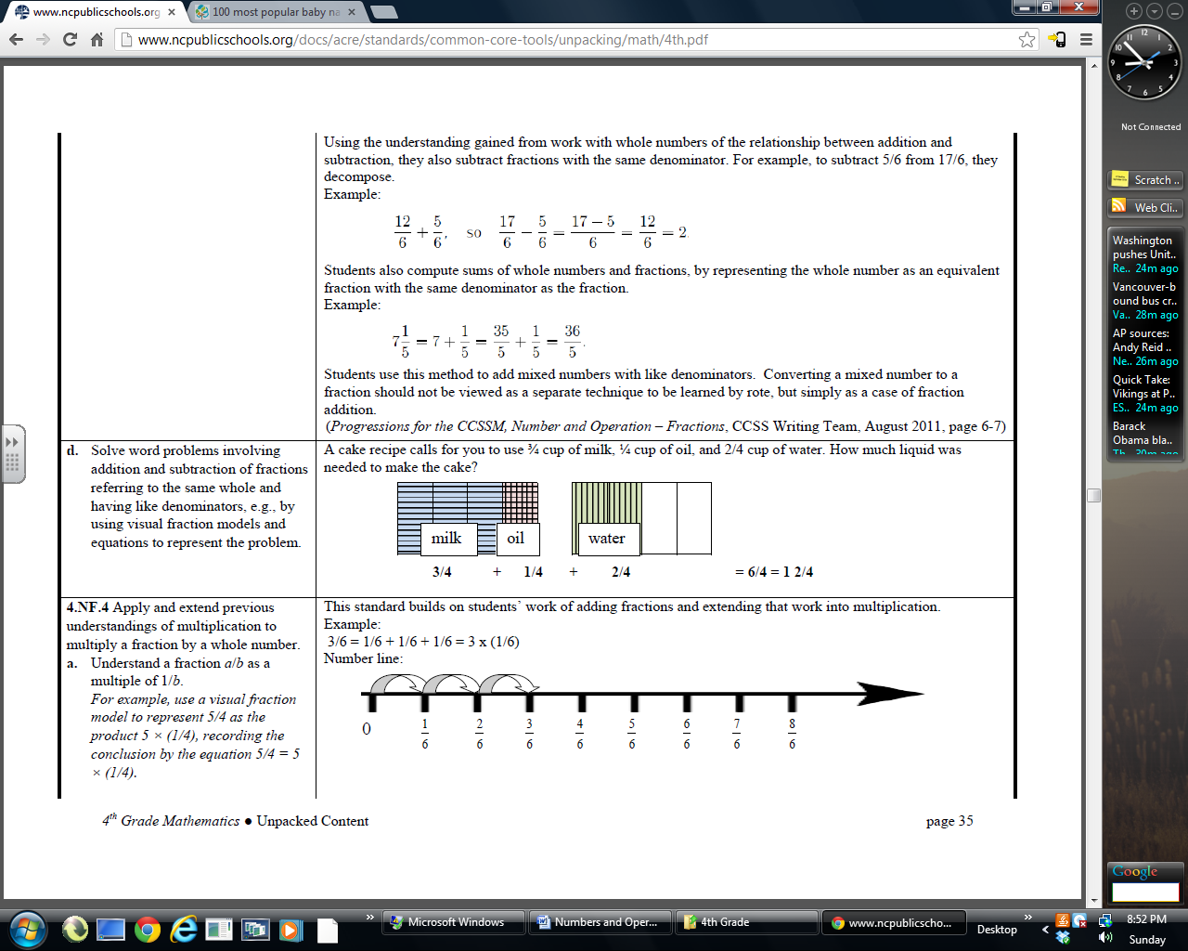

A. $\frac{1}{6}+\frac{1}{6}+\frac{1}{6}$ B. $3×\frac{1}{6}$
C. $\frac{1}{2}−\frac{1}{6}$ D. $\frac{2}{6}+\frac{1}{6}$ E. None of the above

- The mixed number: $7\frac{1}{2}$ is equal to which improper fraction?
A. $\frac{\text{10}}{2}$ B. $\frac{\text{14}}{2}$ C. $\frac{\text{13}}{2}$ D. $\frac{\text{15}}{2}$ E. None of the above

- What is $\frac{5}{8}+\frac{5}{8}$?

A. $1\frac{1}{4}$ B. $\frac{\text{10}}{\text{16}}$ C. $\frac{5}{8}$ D. $1\frac{2}{5}$ E. None of the above

- Which of the following inequalities is correct when comparing 0.32 and 0.34?

A. 0.32 < 0.34 B. 0.32 > 0.34
C. 0.34 < 0.32 D. 0.32 = 0.34 E. None of the above

- Which figure does NOT show a fraction equivalent to 0.5 shaded in?
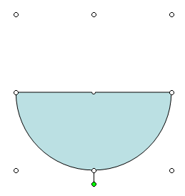
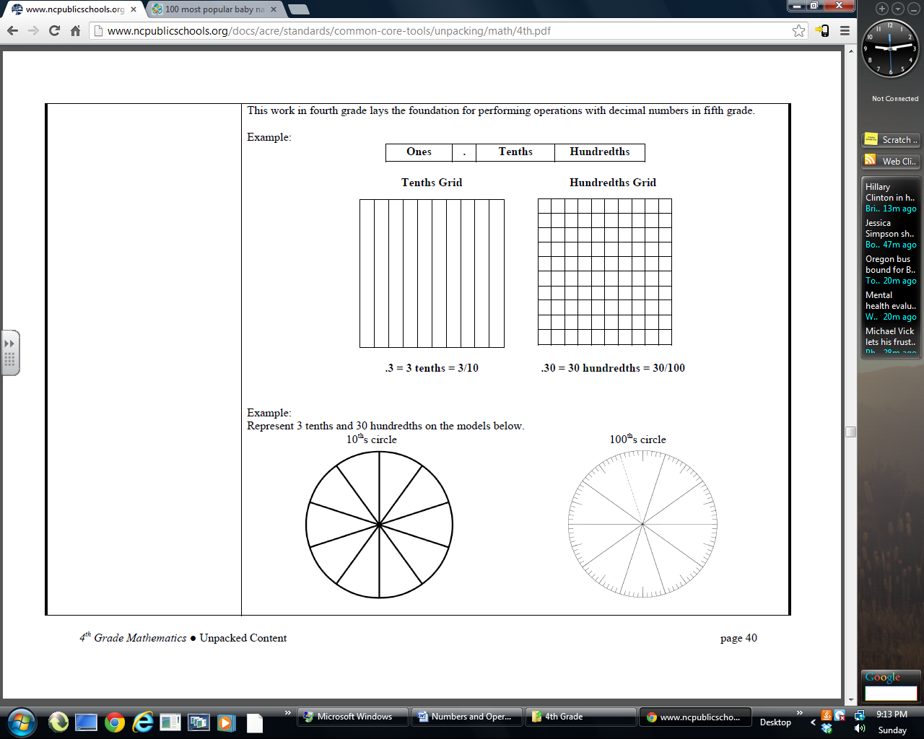 | B.
C. | D. | E. None of the above

- Use the diagram to list the fractions from least to greatest?
5
8
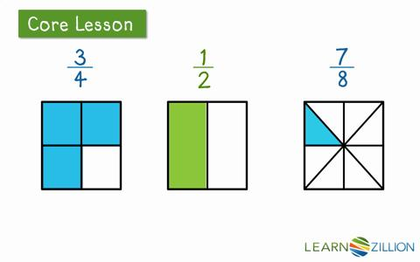

A. $\frac{3}{4},\frac{1}{2},\frac{5}{8}$ B. $\frac{1}{2},\frac{5}{8},\frac{3}{4}$ C. $\frac{5}{8},\frac{1}{2},\frac{3}{4}$ D. $\frac{1}{2},\frac{3}{4},\frac{5}{8}$ E. None of the above

- Use the fraction strips to compare 5/10 to 5/9. Which statement is true?
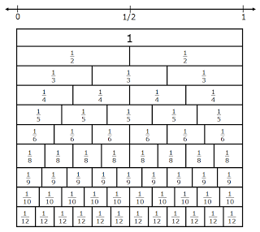
- $\frac{5}{\text{10}}=\frac{5}{9}$ B. $\frac{5}{\text{10}}>\frac{5}{9}$

C. $\frac{5}{9}<\frac{5}{\text{10}}$ D. $\frac{5}{9}>\frac{5}{\text{10}}$

- None of the above

- If A = 0 and E = 1, then what is D?

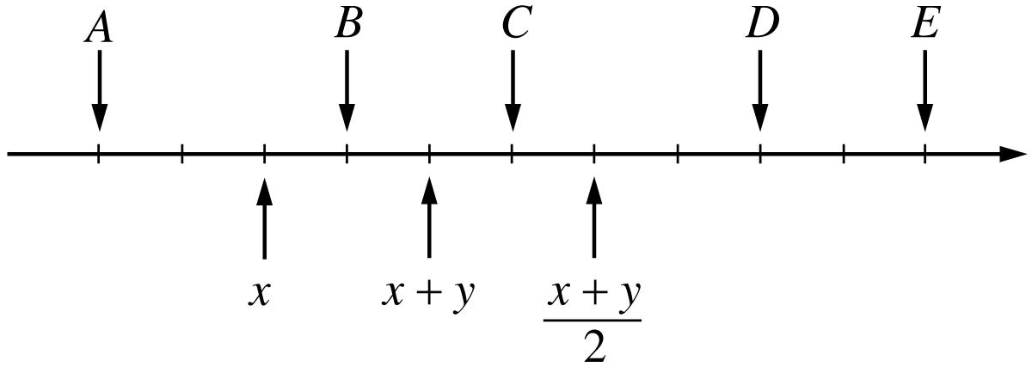

- 0.8 B. 0.9 C. $\frac{9}{\text{10}}$ D. $\frac{9}{\text{11}}$ E. None of the above

- 6,000 – 1,999

A. 4,111 B. 4,001 C. 4,011 D. 4,101 E. None of the above

- $$\frac{1}{4}+\frac{3}{4}+\frac{1}{4}$$

A. $1\frac{1}{4}$ B. $1\frac{1}{2}$ C. $\frac{5}{\text{12}}$ D. $1\frac{3}{4}$ E. None of the above

- $$\frac{3}{4}×\frac{3}{4}$$

A. $\frac{1}{2}$ B. $\frac{3}{4}$ C. $1\frac{1}{8}$ D. $\frac{9}{\text{16}}$ E. None of the above

- $$7\frac{4}{5}−3\frac{1}{5}$$

A. 4 B. $4\frac{3}{5}$ C. $3\frac{2}{5}$ D. $5\frac{1}{5}$ E. None of the above

- 403 ÷ 5

A. 80 r 2 B. $\text{80}\frac{3}{5}$ C. $8\frac{3}{5}$ D. $\text{81}\frac{1}{5}$ E. None of the above

- 4 x (5 + 9)

A. 180 B. 29 C. 60 D. 56 E. None of the above

- 22 – (3 + 10)

A. 19 B. 9 C. 29 D. 34 E. None of the above

- 24 + 8 ÷ 4

A. 8 B. 36 C. 26 D. 7 E. None of the above

- $1\frac{2}{3}×3$
A. 5 B. $\frac{5}{3}$ C. 3 D. $3\frac{2}{3}$ E. None of the above

- 300 ÷ 10

A. 3 B. 30 C. 0.3 D. 0.03 E. None of the above

- $5.00 ÷ 25

A. 20 B. 21 C. 23 D. 25 E. None of the above

- $\frac{3}{4}×\text{16}$

A. $\frac{\text{19}}{4}$ B. $\frac{\text{19}}{\text{20}}$ C. 12 D. 7 E. None of the above

- 435 + 39 + 241

A. 474 B. 705 C. 615 D. 715 E. None of the above

- $7.58 + $1.79

A. $9.37 B. $8.21 C.$12.21 D. $12.09 E. None of the above

- What change will the cashier give you if you purchase 4 apples at $0.25 each,
one box of crackers for $1.70, and a Gatorade for $1.40. You give the cashier $5.

- $0.90 B. $1.65 C. $1.90 D. $4.10 E. None of the above

For question #35, there are four problems that have been worked. One of the problems has an incorrect answer. Identify the problem that has an incorrect answer.

35. A. 24,176 B. 41,564 C. 97 D. 567 ÷ 4 = 141 r 3
5,287 - 5,678 x 23
+ 68,009 35,996 2,231 E. None of the above
97,472

36. Find the missing digits A, B, C, and D in the problem:

a 3 8 A. a = 2, b = 4, c = 3, d = 1
8 b 6 B. a = 4, b = 5, c = 3, d = 2
1 4 c C. a = 5, b = 3, c = 2, d = 1
d 4 0 7 D. a = 4, b = 2, c = 3, d = 1
E. None of the above

Determine the closest estimate for problems 37- 40.
37. 5.1 x 200 A. 1100 B. 1000 C. 1200 D. 1300

- 695 ÷ 10 A. 7 B. 700 C. 70 D. 0.7

- $\left(3\frac{1}{8}\right)+\left(7\frac{\text{11}}{\text{12}}\right)−\left(1\frac{\text{19}}{\text{20}}\right)$ A. 13 B. 10 C. 8 D. 9

- What is the approximate cost of taking a 1000 mile trip if you get 20 miles per gallon of gas and the gas costs $3.06 per gallon?

- $150 B. $300 C. $600 D. $200

Shade the correct answer! Name______________________
Example: A B C D E
School _____________________

1. A B C D E | 21. A B C D E
2. A B C D E | 22. A B C D E
3. A B C D E | 23. A B C D E
4. A B C D E | 24. A B C D E
5. A B C D E | 25. A B C D E
6. A B C D E | 26. A B C D E
7. A B C D E | 27. A B C D E
8. A B C D E | 28. A B C D E
9. A B C D E | 29. A B C D E
10. A B C D E | 30. A B C D E
11. A B C D E | 31. A B C D E
12. A B C D E | 32. A B C D E
13. A B C D E | 33. A B C D E
14. A B C D E | 34. A B C D E
15. A B C D E | 35. A B C D E
16. A B C D E | 36. A B C D E
17. A B C D E | 37. A B C D E
18. A B C D E | 38. A B C D E
19. A B C D E | 39. A B C D E
20. A B C D E | 40. A B C D E

Shade the correct answer! Name______________________
Example: A B C D E
School _____________________
ANSWER KEY

1. A B C D E | 21. A B C D E
2. A B C D E | 22. A B C D E
3. A B C D E | 23. A B C D E
4. A B C D E | 24. A B C D E
5. A B C D E | 25. A B C D E
6. A B C D E | 26. A B C D E
7. A B C D E | 27. A B C D E
8. A B C D E | 28. A B C D E
9. A B C D E | 29. A B C D E
10. A B C D E | 30. A B C D E
11. A B C D E | 31. A B C D E
12. A B C D E | 32. A B C D E
13. A B C D E | 33. A B C D E
14. A B C D E | 34. A B C D E
15. A B C D E | 35. A B C D E
16. A B C D E | 36. A B C D E
17. A B C D E | 37. A B C D E
18. A B C D E | 38. A B C D E
19. A B C D E | 39. A B C D E
20. A B C D E | 40. A B C D E

