Kansas City Area Teachers of Mathematics
2013 KCATM Math Competition

GEOMETRY AND MEASUREMENT TEST GRADE 5

INSTRUCTIONS

• Do not open this booklet until instructed to do so.

• Time limit: 15 minutes

• You may use calculators on this test.

• Use the π key on your calculator or 3.14159 as the approximation for pi.

• Mark your answer on the answer sheet by FILLING in the oval.

• You may not use rulers, protractors, or other measurement devices on this test.

Student Name ____________________________ Student Number _______

School __________________________________

51. What is the volume of the rectangular solid shown in Figure 1. Figures 2 and 3 might help you.
Figure 1
Figure 2
Figure 3

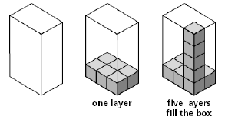 | A. 6 cubic units  B. 11 cubic units  C. 24 cubic units  D. 30 cubic units  E. None of the above
52. The net below is of an open topped rectangular solid. What is the volume of the rectangular solid?
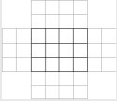
- 12 cubic units
- 18 cubic units
- 24 cubic units
- 36 cubic units
- None of the above

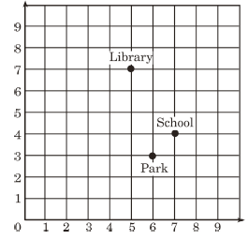
Use the coordinate grid for problems 53-55.

53. What are the coordinates of the school?
A. (6,3) B. (5,7) C. (4,7) D. (7,4)
E. None of the above

54. Name the coordinates of another point that would form
a parallelogram with the library, school, the park.
A. (7,5) B. (6,8) C. (4,5) D. (3,6)
E. None of the above

55. What is the area of the coordinate grid?
A. 9 units B. 81 sq. units C. 90 sq. units D. 100 sq. units E. None of the above

56. Walking is one of the easiest forms of exercise. The students at your school set a goal to walk around the rectangular playground 40 times in one week. The dimensions of the playground are 200 feet by 220 feet. After the third day, they have 25 laps left to walk. There are 5,280 feet in one mile. How far have the students walked so far? Round your answer to the nearest tenth of a mile?
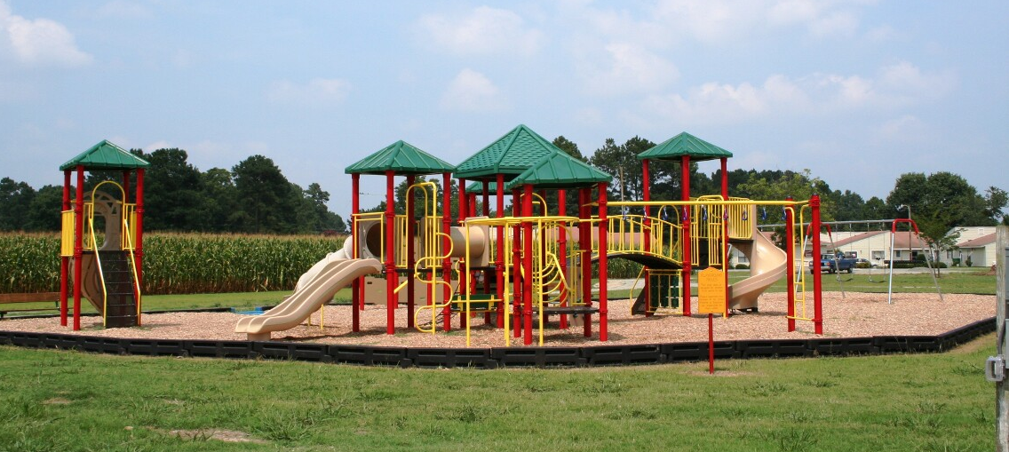
- 2.4 miles
- 6.4 miles
- 8.3 miles
- 15 miles
- None of the above

57. Which answer identifies all of the parallelograms in the figures 1-6?

1 2 3 4 5 6
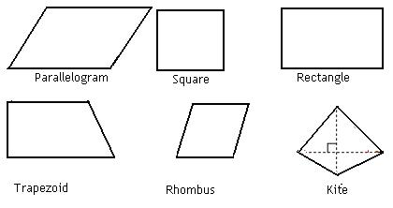

A. Figures 1, 2, 3, 4 B. Figures 1, 3, 5
C. Figures 1, 2, 3, 5 D. Figures 1, 2, 3, 4, 5, 6 E. None of the above

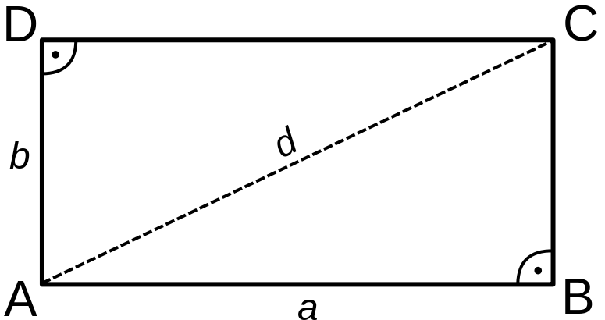
Use the rectangle for problems 58-60.

58. Name 2 sides that are parallel.
A. $\overline{\text{AB}},\overline{\text{BC}}$ B. $\overline{\text{AB}},\overline{\text{DC}}$ C. $\overline{\text{DA}},\overline{\text{DC}}$ D. $\overline{\text{AD}},\overline{\text{AB}}$ E. None of the above

59. Name 2 sides that are perpendicular.
A. $\overline{\text{AC}},\overline{\text{BC}}$ B. $\overline{\text{AB}},\overline{\text{DC}}$ C. $\overline{\text{DC}},\overline{\text{AC}}$ D. $\overline{\text{AD}},\overline{\text{BC}}$ E. None of the above

60. In the rectangle ABCD, one diagonal is “d”. Which statement is NOT true:
A. A rectangle has 4 right angles.
B. The diagonal is a line of symmetry.
C. The diagonal splits the rectangle into 2 congruent triangles.
D. A rectangle is always a parallelogram.
E. All statements are correct.

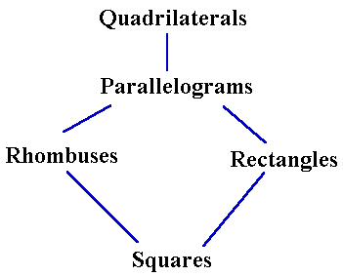
Use the flowchart for problems 61-62:

61. A square is always, sometimes, or never a rhombus?
A. Always B. Sometimes C. Never
D. Not enough information E. None of the above

62. A rectangle is always, sometimes, or never a square?
A. Always B. Sometimes C. Never
D. Not enough information E. None of the above

63. What is the definition of a trapezoid?
A. A quadrilateral with exactly one pair of parallel sides.
B. A quadrilateral with two pair of parallel sides.
C. A parallelogram with one pair of parallel sides.
D. A kite with two sides congruent.
E. None of the above

64. What letter is formed when you connect these points in order on the coordinate grip below.
(2,2), (2,4), (2,6), (2,8), (4,5), (6,8), (6,6), (6,4), and (6,2)
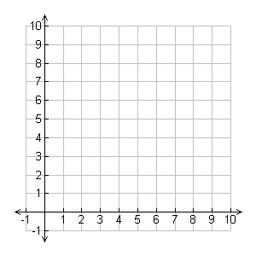

- A

- B

- M

- N

- None of the above

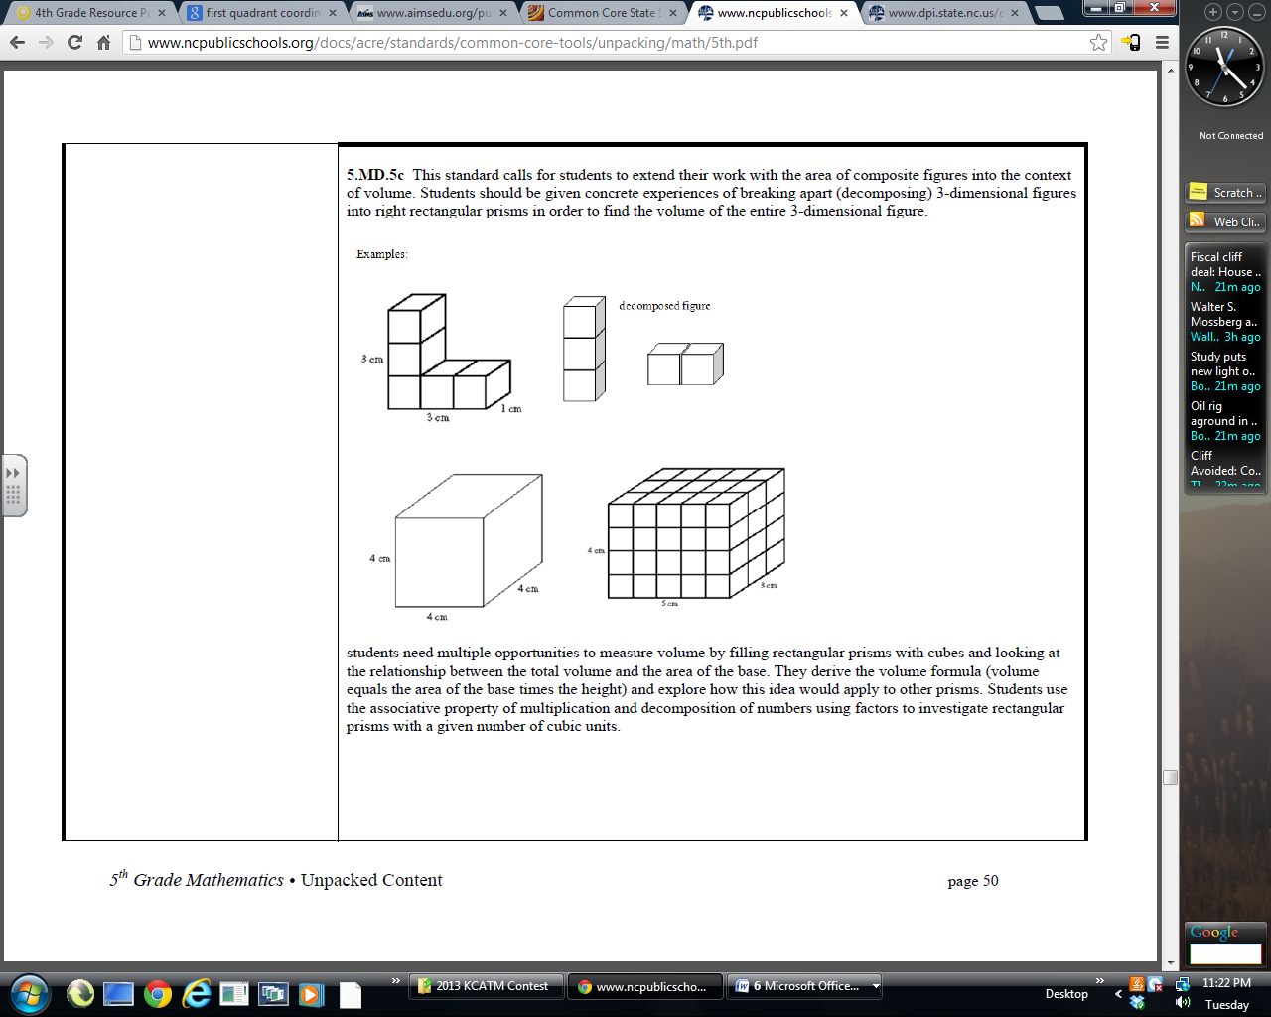
Use the rectangular solid for questions 65-66.
65. What is the volume of the following rectangular solid?
4cm
A. 64 cu. cm. B. 60 cu. cm.
C. 23 cu. cm. D. 12 cu. cm.
3cm
E. None of the above
5cm

66. What is the area of the front face of the solid?
A. 12 sq. cm. B. 15 sq. cm. C. 20 sq. cm. D. 47 sq. cm. E. None of the above

Use the L-shaped solid for questions 67-68.
67. If each of the decomposed shapes are cubes.
What is the volume of the figure?
3cm
A. 11 cu. cm B. 5 cu. cm
C. 6 cu. cm D. 9 cu. cm
1cm
E. None of the above
3cm

68. How many 1cm x 1cm faces does this figure have if you were to wrap it completely with wrapping paper? (total surface area of the figure)
A. 19 sq. units B. 11 sq. units C. 15 sq. units D. 22 sq. units E. None of the above

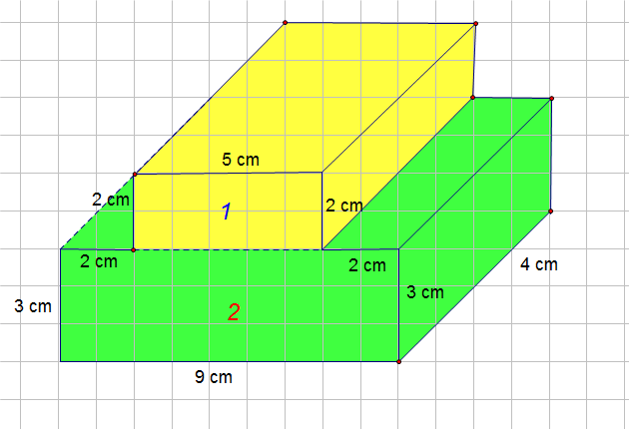
69. Find the volume of the composite shape, the sum of
Figures 1 and 2.
A. 28 cu. cm. B. 108 cu. cm.
C. 333 cu. cm. D. 148 cu. cm.
E. None of the above

Use the figure at the right for problems 70-75.
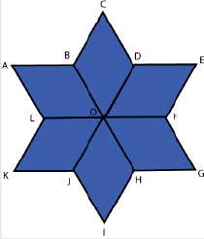
70. When the same shape is repeated over and over again
without gaps, the math term is _____.
A. Parallelogram B. Tessellation
C. Equilateral Triangle D. Symmetry
E. None of the above

71. How many lines of symmetry does the figure have?
A. 3 B. 4 C. 5 D. 6 E. None of the above

72. In quadrilateral ABOL, all sides are equal. What is the shape?
A. Rhombus B. Square
C. Parallelogram D. Kite E. None of the above

73. What is the degree measure of $∠\text{BAL}?$
A. 30º B. 45º C. 60º D. 75º E. None of the above

74. What is the degree measure of $∠\text{ABO}?$
A. 60º B. 120º C. 90º D. 135º E. None of the above

75. What is the degree measure of $∠\text{BOF}?$
A. 120º B. 135º C. 160º D. 180º E. None of the above

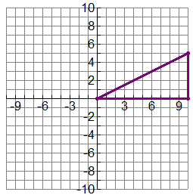
Use the graph for problems 76-79.

76. What is the best descriptor of triangle ABC?
C
A. Equilateral triangle
B. Right isosceles triangle
C. Right scalene triangle
A
B
D. Acute scalene triangle
E. None of the above

77. $\overline{\text{AB}}$is what type of line segment?
A. Vertical B. Horizontal
C. Diagonal D. Not enough information
E. None of the above

78. Name another point on the graph that will form the rectangle ABCD?
A. (0,5) B. (5, 0) C. (10, 5) D. (5,10) E. None of the above

79. Find the area of the triangle ABC.
A. 40 sq. units B. 50 sq. units
C. 35 sq. units D. 12.5 sq. units E. None of the above

80. How do change meters into kilometers?
A. Multiply the number of meters by 100.
B. Multiply the number of meters by 1000.
C. Divide the number of meters by 100.
D. Divide the number of meters by 1000.
E. None of the above

81. A high school basketball player may be 1.905 meters tall, how many centimeters tall is the basketball player?
A. 19.05cm B. 190.5cm C. 1,905cm D. 19,050cm E. None of the above

82. How many grams do you have if you have 5 kilograms of bananas?
A. 0.5g B. 0.005g C. 500g D. 5,000g E. None of the above

83. A milliliter is 20 drops of water. If you have 6,000,000 milliliters, how many liters would you have?
A. 6 liters B. 60 liters C. 600 liters D. 6,000 liters E. None of the above

84. If the football player runs 100 yards, how many feet does he run?
A. 33.3 ft. B. 1200 ft. C. 300 ft. D. 1,000 ft. E. None of the above

85. How many cups are in a container that holds 5 gallons?
A. 80 cups B. 40 cups C. 100 cups D. 50 cups E. None of the above

86. How many quarts are in 7.5 gallons?
A. 2 quarts B. 30 quarts C. 15 quarts D. 60 quarts E. None of the above

87. How many feet are in 20 miles?
A. 20,000 ft. B. 240 ft. C. 105,600 ft. D. 5,280 ft. E. None of the above

88. If a baby weighed 8 ½ pounds, how many ounces did the baby weigh?
A. 68 oz. B. 85 oz. C. 128 oz. D. 136 oz. E. None of the above

89. How do you change inches into feet?
A. Multiply by 3 B. Multiply by 12
C. Divide by 3 D. Divide by 12 E. None of the above

90. The conversion between inches to centimeter is 1 inch = 2.54cm. How many centimeters are there in one foot?
A. 4.72cm B. 30.48cm C. 0.21cm D. 25.4cm E. None of the above

Shade the correct answer! Name______________________
Example: A B C D E
School _____________________

51. A B C D E | 71. A B C D E
52. A B C D E | 72. A B C D E
53. A B C D E | 73. A B C D E
54. A B C D E | 74. A B C D E
55. A B C D E | 75. A B C D E
56. A B C D E | 76. A B C D E
57. A B C D E | 77. A B C D E
58. A B C D E | 78. A B C D E
59. A B C D E | 79. A B C D E
60. A B C D E | 80. A B C D E
61. A B C D E | 81. A B C D E
62. A B C D E | 82. A B C D E
63. A B C D E | 83. A B C D E
64. A B C D E | 84. A B C D E
65. A B C D E | 85. A B C D E
66. A B C D E | 86. A B C D E
67. A B C D E | 87. A B C D E
68. A B C D E | 88. A B C D E
69. A B C D E | 89. A B C D E
70. A B C D E | 90. A B C D E

Shade the correct answer! Name______________________
Example: A B C D E
School _____________________
ANSWER KEY

51. A B C D E | 71. A B C D E
52. A B C D E | 72. A B C D E
53. A B C D E | 73. A B C D E
54. A B C D E | 74. A B C D E
55. A B C D E | 75. A B C D E
56. A B C D E | 76. A B C D E
57. A B C D E | 77. A B C D E
58. A B C D E | 78. A B C D E
59. A B C D E | 79. A B C D E
60. A B C D E | 80. A B C D E
61. A B C D E | 81. A B C D E
62. A B C D E | 82. A B C D E
63. A B C D E | 83. A B C D E
64. A B C D E | 84. A B C D E
65. A B C D E | 85. A B C D E
66. A B C D E | 86. A B C D E
67. A B C D E | 87. A B C D E
68. A B C D E | 88. A B C D E
69. A B C D E | 89. A B C D E
70. A B C D E | 90. A B C D E

