Kansas City Area Teachers of Mathematics
2013 KCATM Contest

GEOMETRY AND MEASUREMENT TEST GRADE 4

INSTRUCTIONS

• Do not open this booklet until instructed to do so.

• Time limit: 15 minutes

• You may use calculators on this test.

• Use the π key on your calculator or 3.14 as the approximation for pi.

• Mark your answer on the Scantron sheet by FILLING in the circle.

• You may not use rulers, protractors, or other measurement devices on this test.

Student Name ____________________________ Student Number _______

School __________________________________

51. Which figure shows a line segment? | 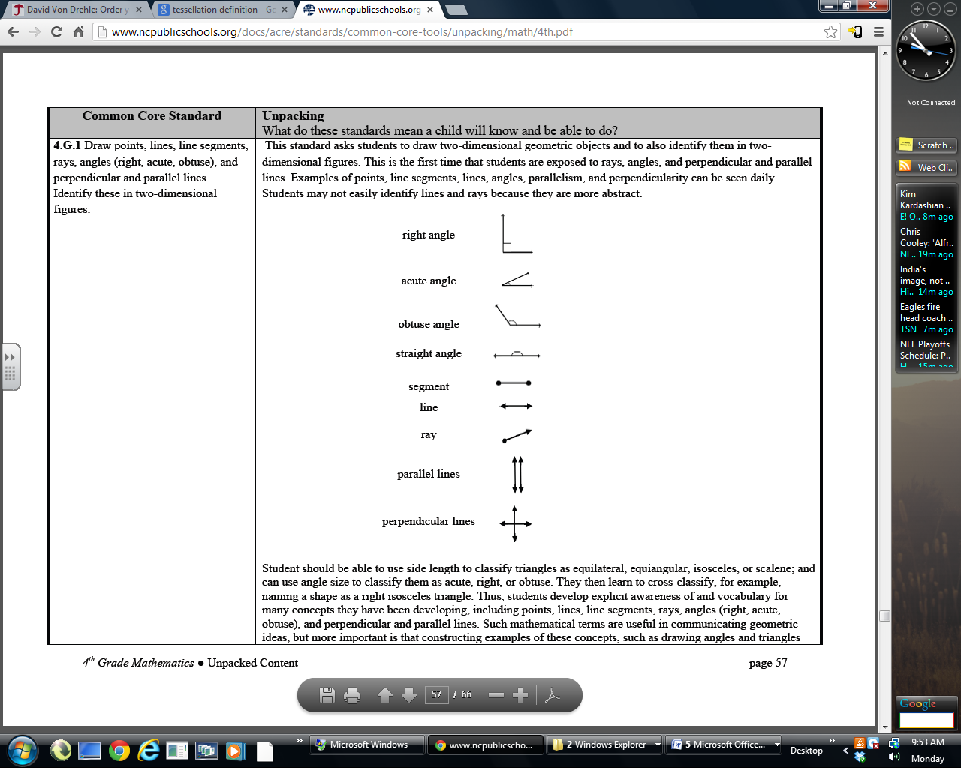  A. B.  C. D.  E. None of the above
52. Which figure shows perpendicular lines? | A. B.  C. D.  E. None of the above
53. Which figure shows an acute angle? | A. B.  C. D.  E. None of the above
54. What is the measure of the angle ($∠\text{AOB}$) marked on the protractor?
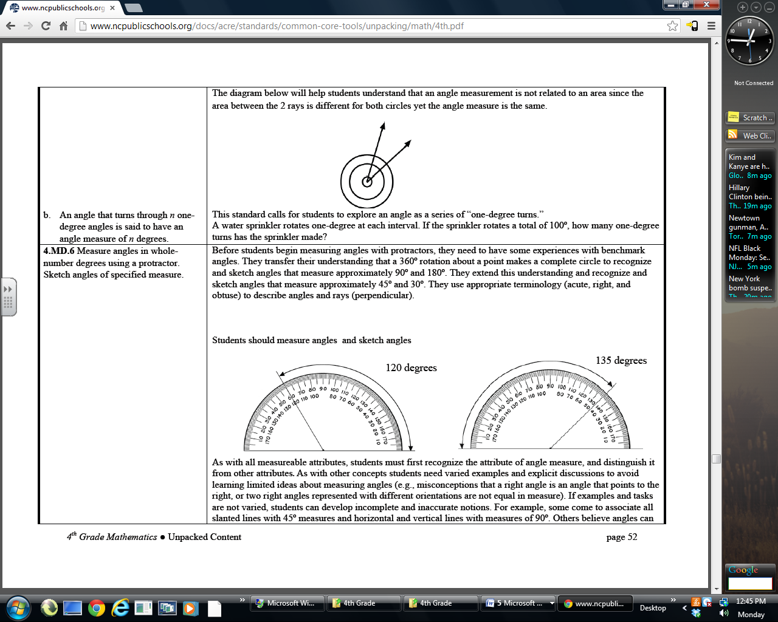
B
A
0

- 45º B. 41º C. 130º D. 135º E. None of the above

55. What is the measure of the missing angle, xº?  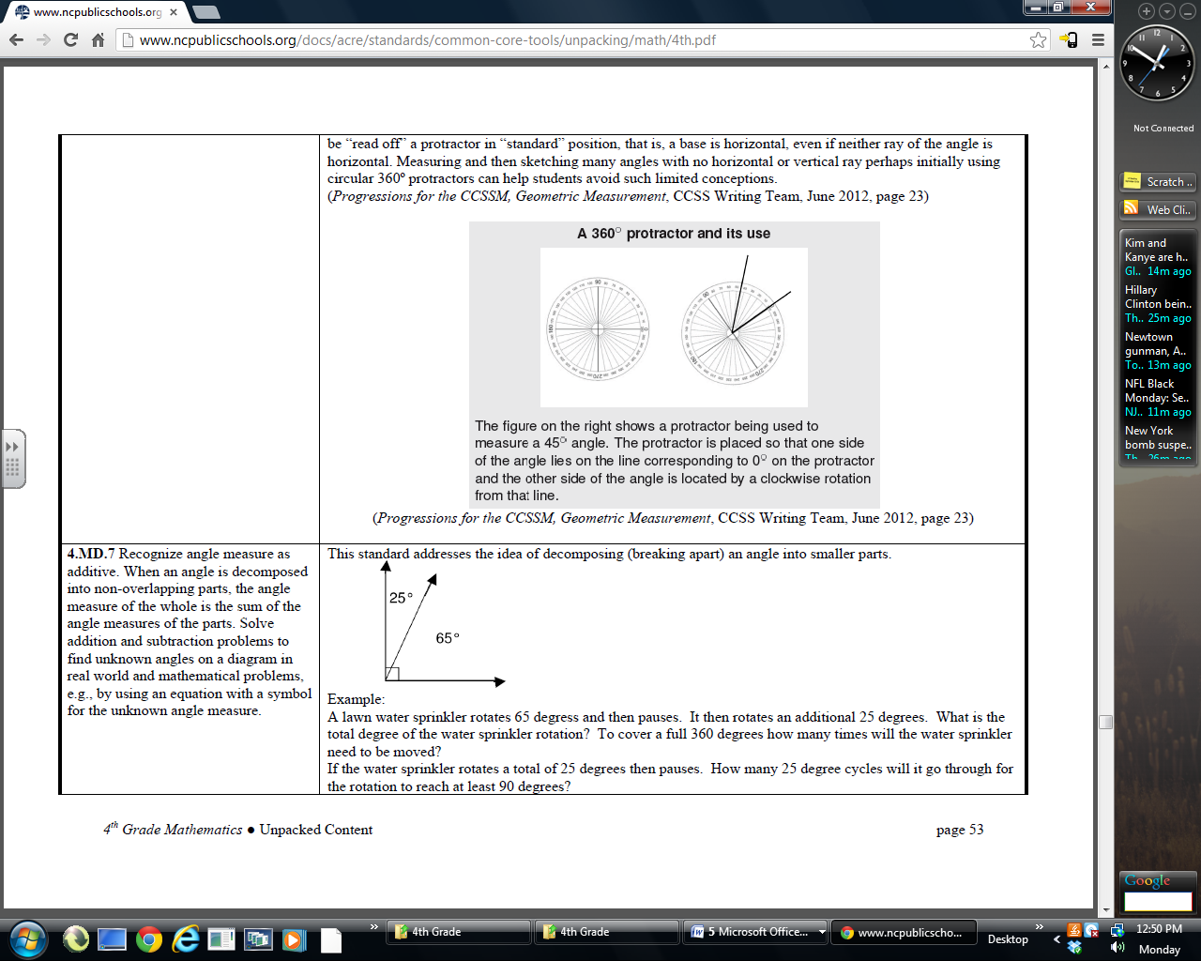  xº | - 25º B. 65º  C. 90º D. 155º  E. None of the above
56. What is the name that describes all four-sided figures?
A. parallelograms B. kites
C. quadrilaterals D. trapezoids E. None of the above

57. The Trans-Alaska Pipeline was built to move oil 800 miles, or 1287 kilometers, from Prudhoe Bay in the northern region of Alaska to Valdez, where it is pumped aboard tankers. What would be the length of the pipeline in hectometers?

- 1,287 hm B. 12,870 hm
C. 128,700 hm D. 1287,000 hm E. None of the above

58. How could you classify this triangle?  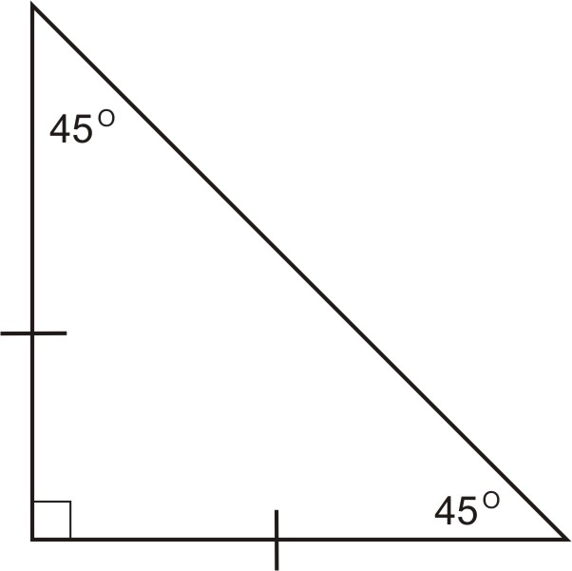 | - Isosceles right triangle  - Scalene right triangle  - Obtuse isosceles triangle  - Acute scalene triangle  E. None of the above
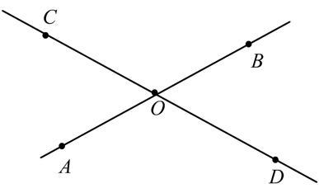  59. What is the measure of $∠\text{COB}$if the measure of $∠\text{BOD}$is 49º ?  49º  60. If the hands on a clock are at exactly 12 and 1, the degrees between them is 30º. What is the measure if the hands on the clock are at exactly 2 and 7?  - 90º B. 120º  C. 135º D. 80º E. None of the above |  | - 49º B. 31º  C. 149º D. 131º  - None of the above  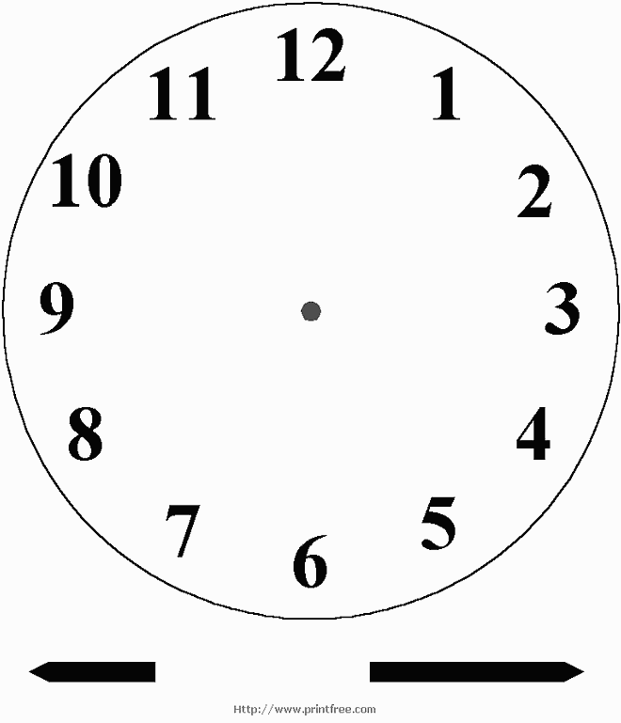
61. Your mom gets up at 6:30am, takes a shower and gets ready for work
in 35 minutes. She wakes you up when she is ready and then spends 23 minutes fixing breakfast. You both sit down to breakfast and spend 17 minutes eating before heading out the door to school and work. What time did you and your mom leave the house? (Use the number line to help.)

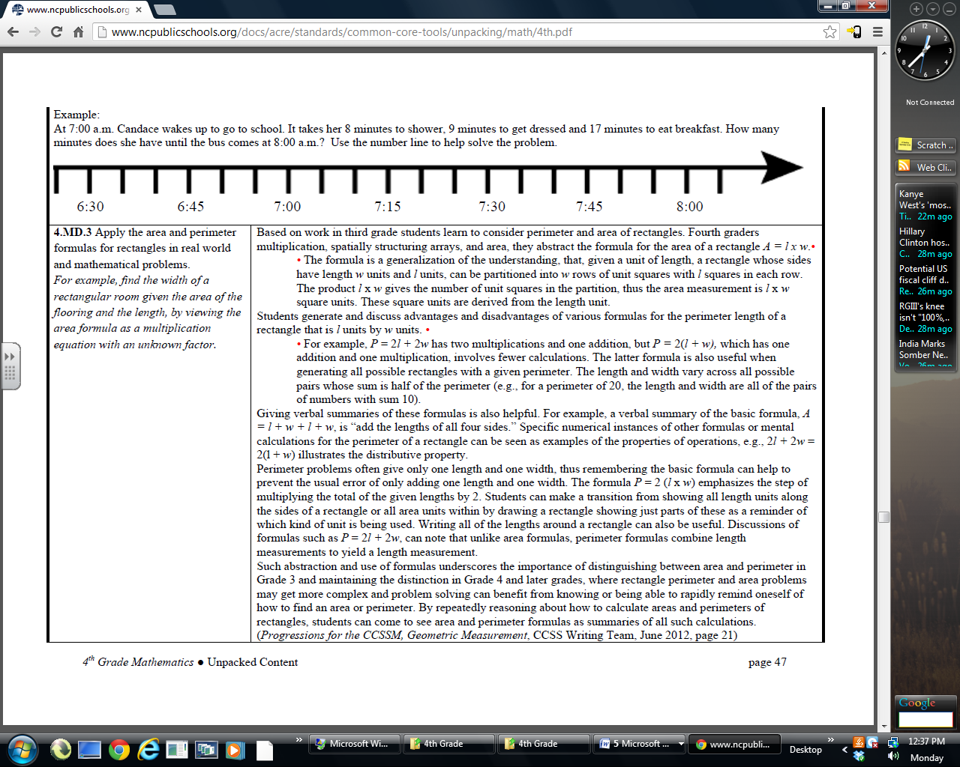

- 7:30am B. 7:40am C. 7:43am D. 7:45am E. None of the above

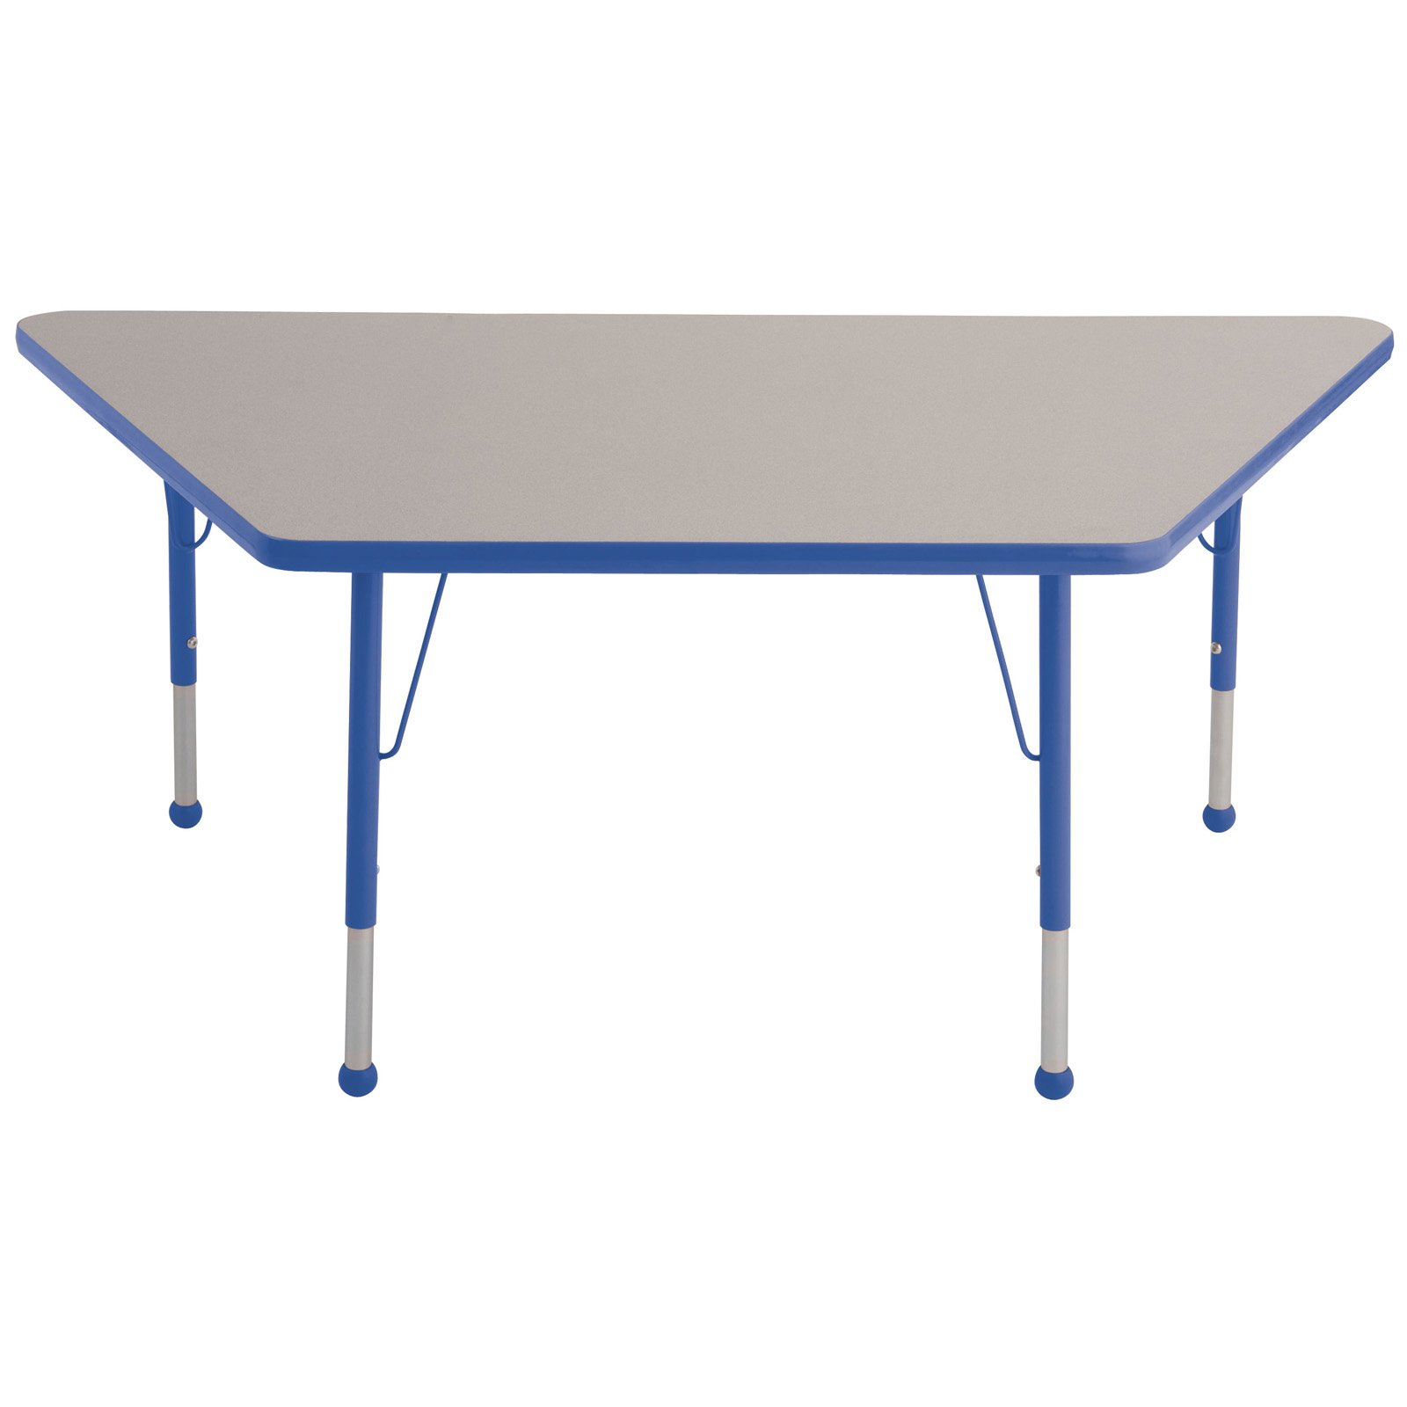
Use the table at the right for problems 62-65.
72º

62. What is the shape of the table?

- Parallelogram B. Rhombus
C. Kite D. Trapezoid E. None of the above

63. If two sides are congruent, then the table is considered what type of shape?
A. Scalene B. Equilateral
C. Isosceles D. Regular E. None of the above

64. If one of the base angles is 72º, what would the other angle measures be?

A. 70º, 100º, 98º B. 108º, 100º, 78º
C. 108º, 72º, 108º D. 80º, 100º, 108º E. None of the above

65. How many lines of symmetry does the table have?

A. 1 B. 2 C. 3 D. 4 E. None of the above

66. Fold a piece of paper in half. If you fold it in half three more times, how many
rectangular sections have been formed when it is unfolded?

A. 8 B. 16 C. 6 D. 12 E. None of the above

.
Use the information below for problems 67 and 68: The Quilt-Block History of Pioneer Days tells the story of how quilts fit into the lives of the pioneers who settle America. Two of the quilt patterns are shown below.
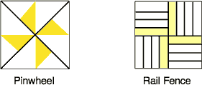

67. What fractional part of the total area is shaded in the Pinwheel pattern?
- 1/8 B. ¼ C. ½ D. 1/16 E. None of the above

68. What decimal fraction is the shaded area in the Rail Fence pattern?
- 0.12 B. 0.20 C. 0.25 D. 0.33 E. None of the above

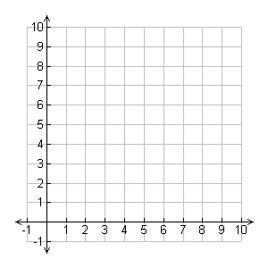
69. On the coordinate plane, draw a continuous line from the starting point to each coordinate. Start at (0,1), and move to (0, 3), (2, 3), (4, 5), (6, 5), (7, 3), (9, 3), (9, 1), (8, 1), (8, 0), (6, 0), (6, 1), (3, 1), (3, 0), (1, 0), (1, 1), (0, 1). What figure did you create?

A. Car B. House
C. Bus D. Boat
E. None of the above

Use the regular polygons for the problems 70-72.
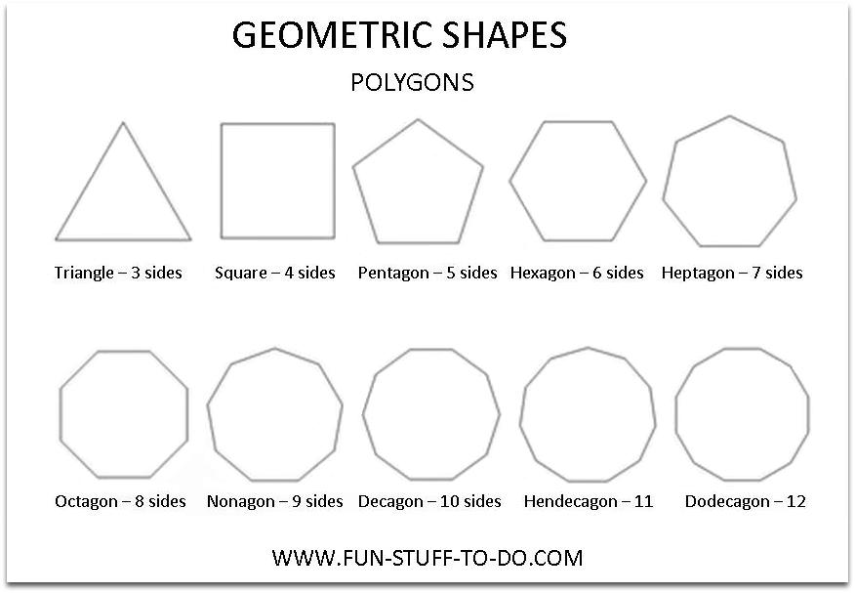

70. Use the pentagon and heptagon to help establish a pattern for the number of lines of symmetry of odd number of sides of regular polygons. What would be the number of lines of symmetry in an odd “n”-sided figure?
A. n B. n – 1 C. n-2 D. (n+1)/2 E. None of the above

71. As the number of sides of a polygon increase, the shape gets closer to the appearance of a ____ and each interior angle becomes more ____.
A. Stop sign, 135º B. Circle; obtuse
C. Line, 180º D. Circle; acute E. None of the above

72. Which regular shape would NOT be able to repeat itself to fill all spaces with
the same shape?
A. Hexagon B. Equilateral triangle
C. Pentagon D. Square E. None of the above
73. What would be the best descriptions for the 2 larger groups in the Venn Diagram below?
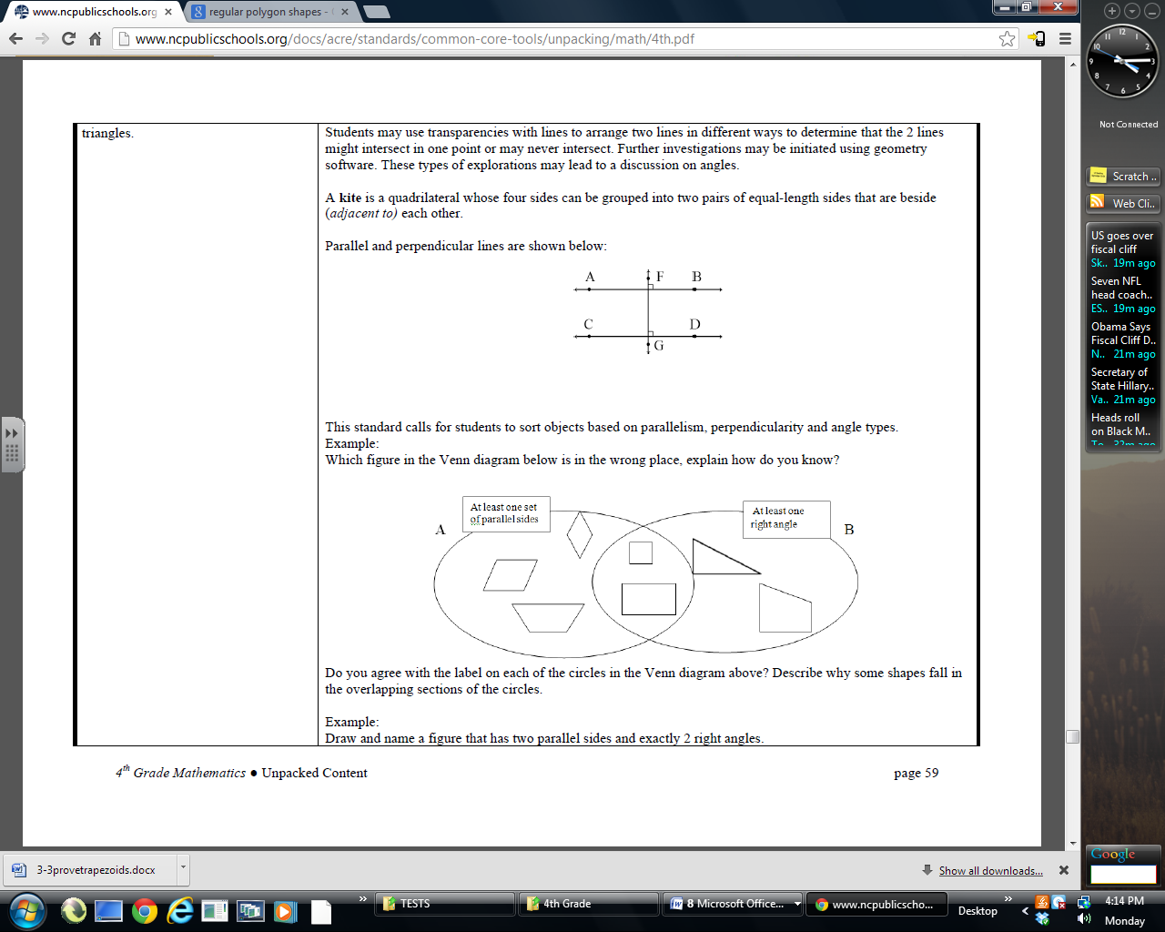
A
B

A. A: quadrilaterals;
B: quadrilaterals with parallel sides

B. A: quadrilaterals with at least one set of parallel sides;
B: shapes with at least one right angle

C. A: regular polygons;
B: one set of perpendicular sides

D. A: quadrilaterals with 2 pair of parallel sides;
B: shapes with at least one right angle

E. None of the above

74. If the perimeter of a rectangle is 18 units and the area is 18 sq. units, which lengths could be the dimensions of the rectangle?
A. 3 x 6 B. 2 x 9 C. 1 x 18 D. 6 x 6 E. None of the above

75. A mile has 5,280 feet. How many yards are in a mile?
A. 2,640 yds. B. 1,680 yds.
C. 1,340 yds. D. 15,840 yds. E. None of the above

76. How many cups are in one gallon?
A. 8 B. 24 C. 16 D. 12 E. None of the above

77. Approximate the percent section C is of the circle.  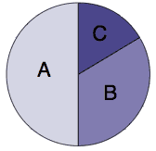 | - 50% B. 25%  C. 33% D. 17%  E. None of the above
78. How many millimeters are in 24.6 cm?
A. 2.46mm B. 24.6mm
C. 246mm D. 2460mm E. None of the above

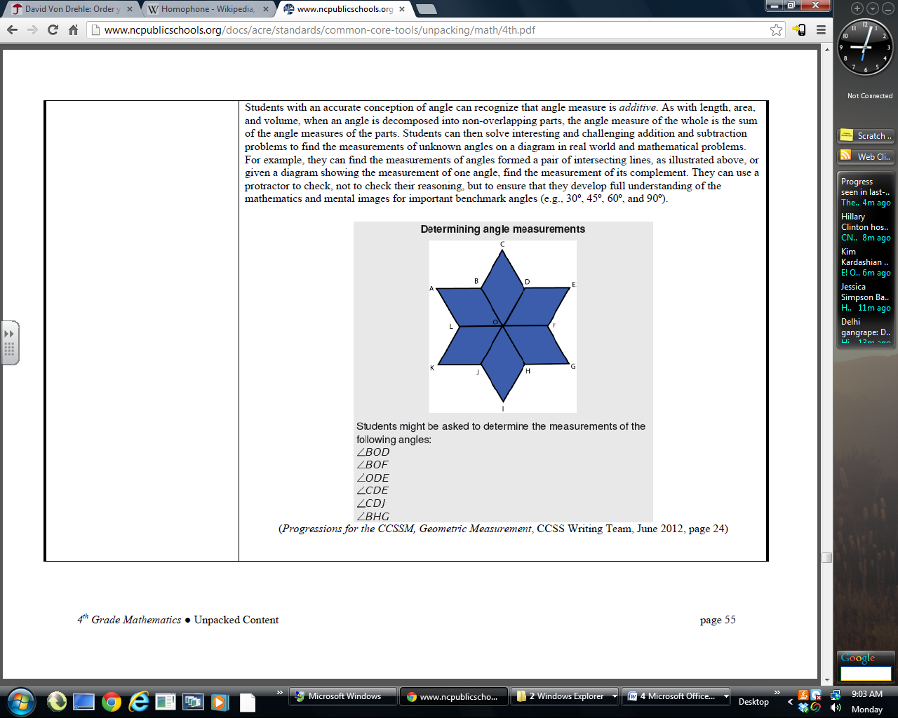
Use the following figure for problems 79- 86.

79. When the same shape is repeated over and over again covering a plane without any gaps or overlaps, the math term is _____.
A. Parallelogram B. Tessellation
C. Equilateral Triangle D. Symmetry
E. None of the above

80. Draw diagonal $\overline{\text{LB}}$ to form equilateral triangles $Δ\text{ABL}$and $Δ\text{BOL}$. If you draw the diagonals$\overline{\text{BD}},\overline{\text{DF}},\overline{\text{FH}},\overline{\text{HJ}},\text{and}\overline{\text{JL}}$, how many equilateral triangles would there be in the whole figure?

A. 6 B. 8 C. 12 D. 2 E. None of the above

81. How many lines of symmetry does the figure have?
A. 3 B. 4 C. 5 D. 6 E. None of the above

82. What is the most specific name for the shape ABOL?
A. Rhombus B. Square
C. Parallelogram D. Star E. None of the above

83. What is the degree measure of $∠\text{BAL}?$
A. 30º B. 45º C. 60º D. 75º E. None of the above

84. What is the degree measure of $∠\text{ABO}?$
A. 60º B. 120º C. 90º D. 135º E. None of the above

85. What is the degree measure of $∠\text{BOF}?$
A. 120º B. 135º C. 160º D. 180º E. None of the above

86. What is the degree measure of $∠\text{LOF}?$
A. 120º B. 135º C. 160º D. 180º E. None of the above

87. Which of the following line plots show the graph of the number of hours eighteen students at your school read during the first 4 weeks of 2013?
14, 14, 8, 6, 10, 20, 16, 8, 8, 14, 12, 16, 20, 6, 10, 12, 20, 16
  A.
   | X |  |  | X |  |  | X
  X | X | X | X | X | X |  | X
  X | X | X | X | X | X | X | X
  6 | 8 | 10 | 12 | 14 | 16 | 18 | 20
  B.
   | X |  |  | X | X |  | X
   | X | X | X | X | X |  | X
  X | X | X | X | X | X |  | X
  6 | 8 | 10 | 12 | 14 | 16 | 18 | 20
C. | D.
   |  |  | X | X | X |  | X
  X | X | X | X | X | X |  | X
  X | X | X | X | X | X |  | X
  6 | 8 | 10 | 12 | 14 | 16 | 18 | 20
   | X |  |  | X | X |  | X
  X | X | X | X | X | X |  | X
  X | X | X | X | X | X |  | X
  6 | 8 | 10 | 12 | 14 | 16 | 18 | 20

Use this figure for problems 88-89. The measures are in centimeters.
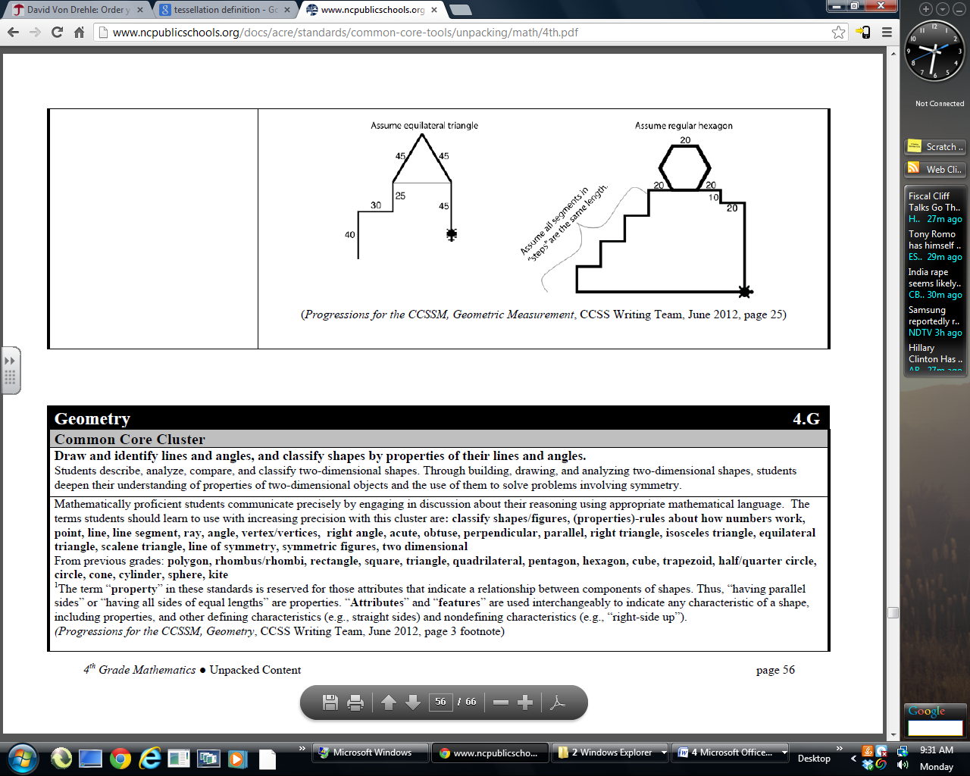
20cm
20
20cm

88. If the bug in the bottom right corner walks around the entire outside figure, how far does the bug walk in centimeters?
A. 520cm B. 560cm C. 500cm D. 480cm E. None of the above

89. If the bug does NOT go around the regular hexagon, but is able to walk straight on the horizontal line, how far would the bug walk in centimeters?
A. 360cm B. 460cm C. 420cm D. 400cm E. None of the above

90. If you traveled to England for the 2012 Summer Olympics, which money system did you use?
A. Dollars B. Pesos
C. Euros D. Pounds E. None of the above

Shade the correct answer! Name______________________
Example: A B C D E
School _____________________

51. A B C D E | 71. A B C D E
52. A B C D E | 72. A B C D E
53. A B C D E | 73. A B C D E
54. A B C D E | 74. A B C D E
55. A B C D E | 75. A B C D E
56. A B C D E | 76. A B C D E
57. A B C D E | 77. A B C D E
58. A B C D E | 78. A B C D E
59. A B C D E | 79. A B C D E
60. A B C D E | 80. A B C D E
61. A B C D E | 81. A B C D E
62. A B C D E | 82. A B C D E
63. A B C D E | 83. A B C D E
64. A B C D E | 84. A B C D E
65. A B C D E | 85. A B C D E
66. A B C D E | 86. A B C D E
67. A B C D E | 87. A B C D E
68. A B C D E | 88. A B C D E
69. A B C D E | 89. A B C D E
70. A B C D E | 90. A B C D E

Shade the correct answer! Name______________________
Example: A B C D E
School _____________________
ANSWER KEY

51. A B C D E | 71. A B C D E
52. A B C D E | 72. A B C D E
53. A B C D E | 73. A B C D E
54. A B C D E | 74. A B C D E
55. A B C D E | 75. A B C D E
56. A B C D E | 76. A B C D E
57. A B C D E | 77. A B C D E
58. A B C D E | 78. A B C D E
59. A B C D E | 79. A B C D E
60. A B C D E | 80. A B C D E
61. A B C D E | 81. A B C D E
62. A B C D E | 82. A B C D E
63. A B C D E | 83. A B C D E
64. A B C D E | 84. A B C D E
65. A B C D E | 85. A B C D E
66. A B C D E | 86. A B C D E
67. A B C D E | 87. A B C D E
68. A B C D E | 88. A B C D E
69. A B C D E | 89. A B C D E
70. A B C D E | 90. A B C D E

