Kansas City Area Teachers of Mathematics
2013 KCATM Math Competition

ALGEBRAIC REASONING
GRADE 5

INSTRUCTIONS

• Do not open this booklet until instructed to do so.

• Time limit: 15 minutes

• You may use calculators on this test.

• Use the π key on your calculator or 3.14 as the approximation for pi.

• Mark your answer on the answer sheet by FILLING in the oval.

• You may not use rulers, protractors, or other measurement devices on this test.

Student Name ____________________________ Student Number _______

School __________________________________

101. When you evaluate the expression: 2 {5 [12 + 5 (500 – 100) + 399]},
what do you do first?
A. Multiply: 2 x 5 B. Add: 12 + 5 C. Subtract: 500 - 100
D. Multiply: 5 x 500 E. None of the above

102. Evaluate: 26 + 18 ÷ 4 + 2
A. 50 B. 13. C. 29. D. 32.5 E. None of the above

103. Evaluate: $6−\left(\frac{1}{2}+\frac{1}{3}\right)$
A. $5\frac{3}{5}$ B. $5\frac{5}{6}$ C. $5\frac{1}{6}$ D. $5\frac{2}{3}$ E. None of the above

104. The following two rules make a table of values. What is the relationship between the 5th term of both rules given the starting value of zero?
Rule A: Add 3 to the previous number.
Rule B: Add 6 to the previous number.

 | - Rule A term is 5 more than Rule B  - Rule A term is 5 less than Rule B  - Rule A is one half Rule B  - Rule A is three more than Rule B  - None of the above
  Term # | Rule A | Rule B
  1 | 0 | 0
  2
  3
  4
  5

105. The graph below is the graph of the number of fish caught by President Obama’s daughters Malia and Sasha while on vacation five days. Which conclusion is NOT true?

Catching Fish
(Malia → ; Sasha → )
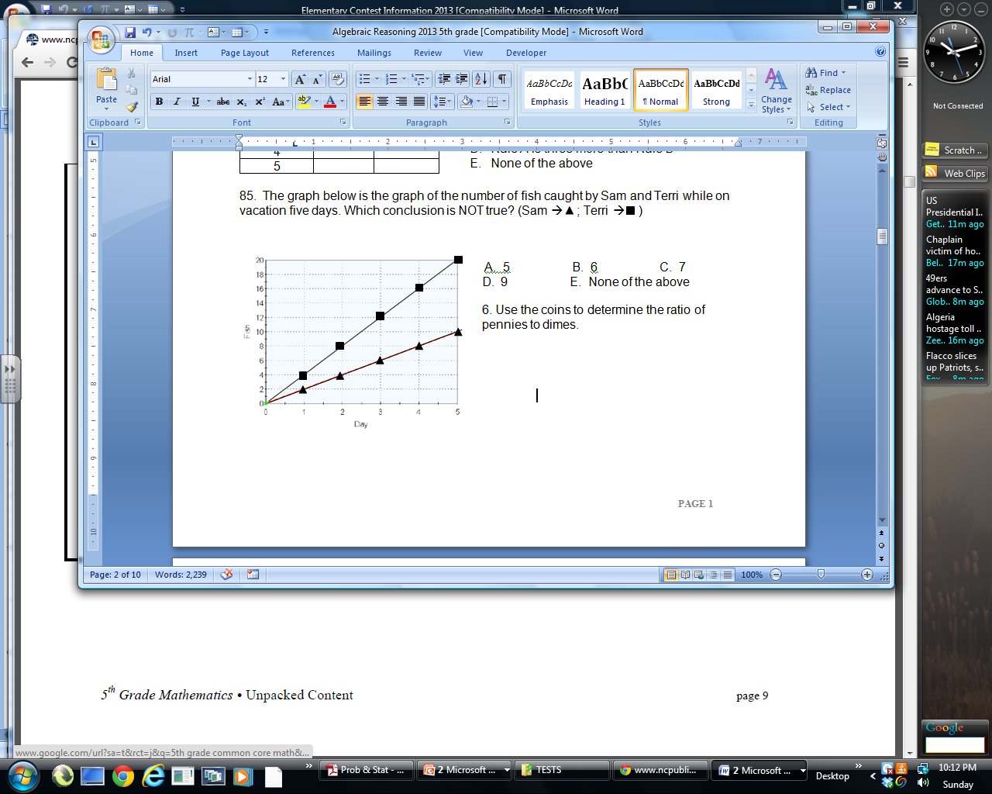
- Sasha caught more fish over the five days of fishing.
- Malia and Sasha never had a day where they caught the same number of fish.
- Each day Malia caught half as many fish than Sasha.
- Each day Sasha always caught 2 more fish than Malia.
- All are true.

106. Looking at the two groups of coins, which equation shows a correct algebraic relationship between the amount of money in Group M versus Group N?

Group M Group N Conclusion
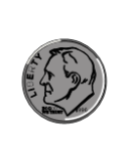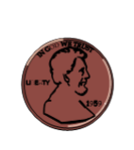   |  | - M = 2N  - N = M – 0.20  - M – 0.05 = N  - M ÷ 2 = N  - None of the above

107. Draw a conclusion about the value of 10⁰, using the scientific notation values below:

10⁻³ = 1/(10 x 10 x 10) = 1/1000  10⁻² = 1/(10x 10) = 1/100  10⁻¹ = 1/10  10⁰ = ___  10¹ = 10  10² = 10 x 10 = 100  10³ = 10 x 10 x 10 = 1000 | - 10⁰ = 1  - 10⁰ = 0  - 10⁰ = 1 x 10 = 10  - 10⁰ = 0.01  - None of the above

108. Triangular numbers and square number patterns are given below. Write a table of values for the terms. What is the difference between the 7th terms?

Triangular Numbers:  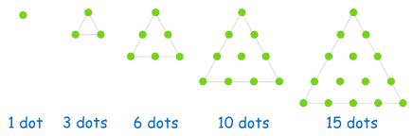
  Term # | Triangular  # | Square  #
  1 | 1 | 1
  2 | 3 | 4
  3
  4
  5
  6
  7
Square Numbers:  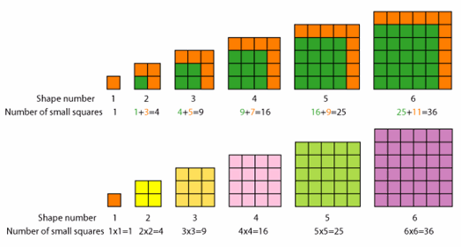 | - 28  - 5  - 14  - 21  - None of the above

109. If r = 8, what is the value of the expression: r ² – 5?
A. 11 B. 59 C. 3 D. 51 E. None of the above

110. How many 1 x 1 unit squares are in the figure below if it is built from all of the perfect squares from 1 x 1 on the top layer to 10 x 10 on the bottom layer?

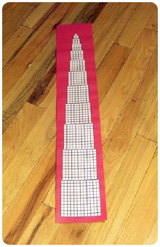 | - 385  - 378  - 304  - 401  - None of the above  http://www.mathactivities.net/lessons/square-numbers-activity.htm

111. What’s the rule?
 | - y = x + 5  - y = 3x – 6  - y = 2x + 1  - y = x + 3  - None of the above
  Input (x) | Output (y)
  2 | 5
  7 | 15
  12 | 25
  18 | 37

Use this magic number trick for problems 112-114:
Write down any positive integer. Add to it the number that comes after it. Add 9.
Divide by 2. Subtract the number you began with to find a new number.

112. What answer is it for every number?
A. 4 B. 5 C. 6 D. 7 E. None of the above

113. If you select the number “7”, which expression shows the order of operations of the magic number trick?

A. 7 + 8 + 9 ÷ 2 – 7 B. 7 + (8 + 9)/2 – 7 C. [(7 + 8) + 9] ÷ 2 – 7
D. (7 + 8) + 9 ÷ 2 – 7 E. None of the above

114. When “n” is the chosen number which algebraic expression shows the correct order for the magic number trick?
A. {[n + (n + 1)] + 9 }÷ 2 – n B. {[n + (n - 1)] + 9 }÷ 2 – n C. n + (n + 1) + 9 ÷ 2 – n
D. [n + (n + 1)] + (9 ÷ 2) – n E. None of the above

115. Manuel wants to save enough money to buy a bicycle. His mom will pay him $8 for each door “d” he paints and $4 for each window frame “w” he paints. If Manuel earned $40 from painting, which of the following would NOT be a way in which he earned the $40?

A. d = 5, w = 0 B. d = 4, w = 2 C. d = 3, w = 4
D. d = 2, w = 7 E. All are correct.

116. Which table shows the data for the linear equation: y = 0.5x + 12 ?
A. B. C. D. E. None of the above
  x | y
  2 | 13
  4 | 14
  6 | 15
  8 | 16
  x | Y
  2 | 22
  4 | 32
  6 | 42
  8 | 52
  X | y
  2 | 12
  4 | 24
  6 | 36
  8 | 48
  x | y
  2 | 7
  4 | 8
  6 | 9
  8 | 10

117. “The sum of the quotient of a number and sixteen and four” is which expression?

A. $\frac{n}{\text{16}}−4$ B. $n+\frac{\text{16}}{4}$ C. 16n + 4 D. $\frac{\text{16}}{n}+4$ E. None of the above

118. “Ten less than the product of eight and a number” is which expression?

A. 8 + x - 11 B. 10 - 8(x) C. 10 (x – 8) D. 8x - 10 E. None of the above

119. Use the graph to compare Day 1 and Day 2. Which fruit had 6 fewer kilograms sold on Day 2 compared to Day 1?
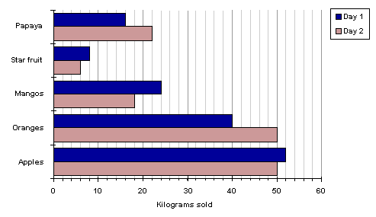  Graph from: http://www.mathleague.com/help/data/data.htm | A. Papaya  B. Star fruit  C. Mangos  D. Apples  E. None of the above

120. In the table of values, determine the missing value for the input of 10?

Input | 4 | 7 | 10 | 13 | 16
Output | -11 | -8 | ? | -2 | 1

A. -9 B. -5 C. -7 D. -4 E. None of the above

121. Find the value for the expression: [3 x (16 – 7)²]
A. 54 B. 363 C. 1681 D. 243 E. None of the above

122. Distribute: 8 (7x - 9) =
A. 55x – 64 B. 56x – 9 C. 56x – 72 D. 15x – 1 E. None of the above

123. Which statement shows the associative property of addition?
A. (7 + 8) + 1 = 7 + (8 + 1) B. (7 + 8) x 1 = 7 x 1 + 8 x 1
C. 7 + (8 + 1) = 7 + 1 + 8 D. (7 x 8) x 1 = 7 x ( 8 x 1) E. None of the above

124. Which statement shows the commutative property of multiplication?
A. (6 + 5) + 8 = 6 + (5 + 8) B. (6 x 5) x 8 = 6 x (5 x 8)
C. 6(5 + 8) = 30 + 48 D. (6 x 5) x 8 = (5 x 6) x 8 E. None of the above

125. Which expression does NOT show another way to divide a number, n, by 2?
A. n/2. B. (½)n C. 0.5(n). D. n ÷ 2 E. All are correct.

126. Given the equation: x (3 + ) = 28, which value should be in the square?

A. 4 B. 5 C. 3 D. 7 E. None of the above

127. If 2.5 x 10^{x} = 2500, what power would “x” have to be to produce an answer of 2,500?
A. 1 B. 2 C. 3 D. 4 E. None of the above

128. Multiplying by the fraction 1/10 is the same as:
A. Multiplying by 10 B. Dividing by 0.10 C. Dividing by 10
D. Multiplying by 0.01 E. None of the above

129. Which decimal expression is the greatest?
A. 0.1234 x 10² B. 1.234 x 10³ C. 0.01234 x 10,000
D. 12.34 x 10¹ E. None of the above

130. Which expression is equivalent to “add 8 and 7, then multiply by 2”?
A. 2 x ( 8 + 7) B. 8 x 2 + 7 C. 8 + 7 x 2
D. 8 + (2 x 7) E. None of the above

131. Given the two data sets below, select the most correct graph that shows the graphs of both data sets. The markings on the graphs are every 5 units.
Data #1 Data #2
 | 0 | 0 |  |  | 0 | 0
 | 5 | 4 |  |  | 1 | 3
 | 10 | 8 |  |  | 2 | 6
 | 15 | 12 |  |  | 3 | 9  2
 | 20 | 16 |  |  | 4 | 12
A.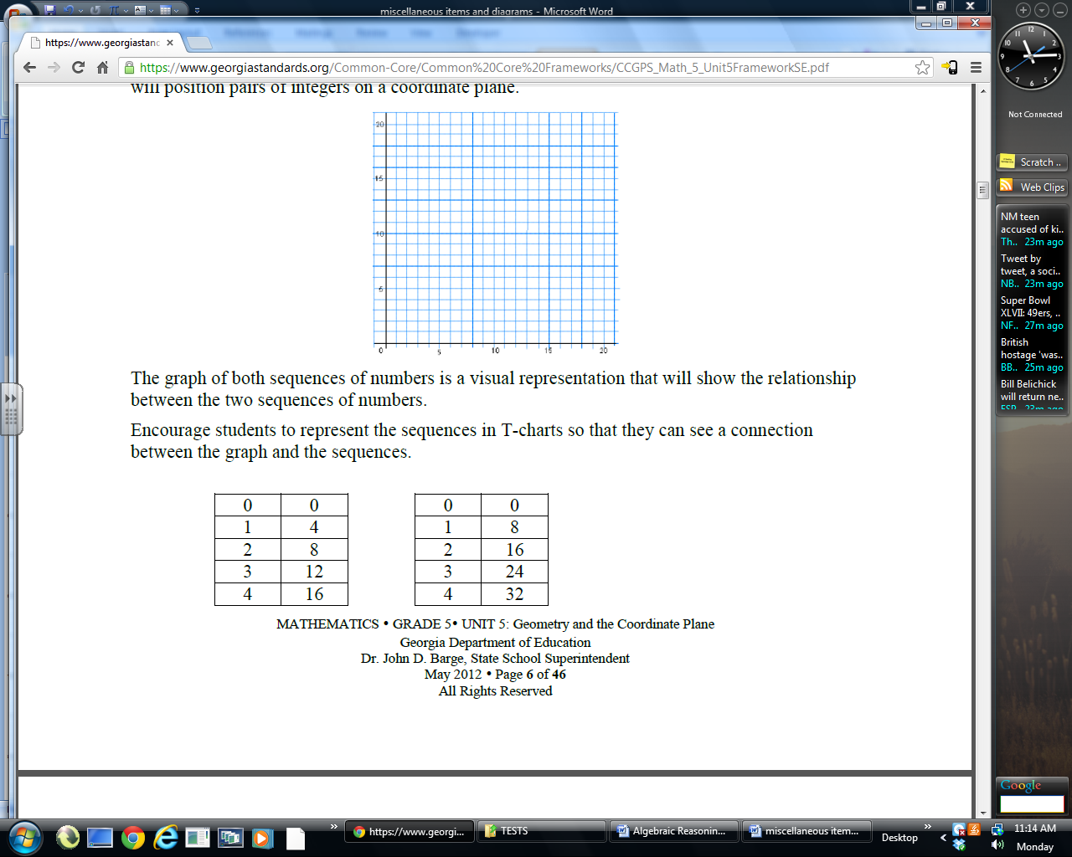  2  1 |  |  |  | B.  2  1
C.  2  1 |  |  |  | D.  1
E. None of the above

132. Let N be a digit from 0-9. Find N in the first subtraction problem, then use that digit to solve the addition problem.

If 8 2 7  - 7 3 N  8 6  Find N. | Use N and solve this problem:  6 1, 7 2 4  + N N N N | - 62,835  - 69,501  - 70,612  - 71,723  - None of the above

133. The problem 3 x (18932 + 921) is the same as thinking:
A. The answer is three times as large as the sum of the two given numbers.
B. The answer is one-third as large as the sum of the two given numbers.
C. The answer is found by multiplying 18,932 by three and adding 921
D. The answer is found by adding the 2 given numbers, then dividing by three.
E. None of the above

134. Use the lattice multiplication chart to compute: 2,314 x 157. What is the value in the bolded triangle location?

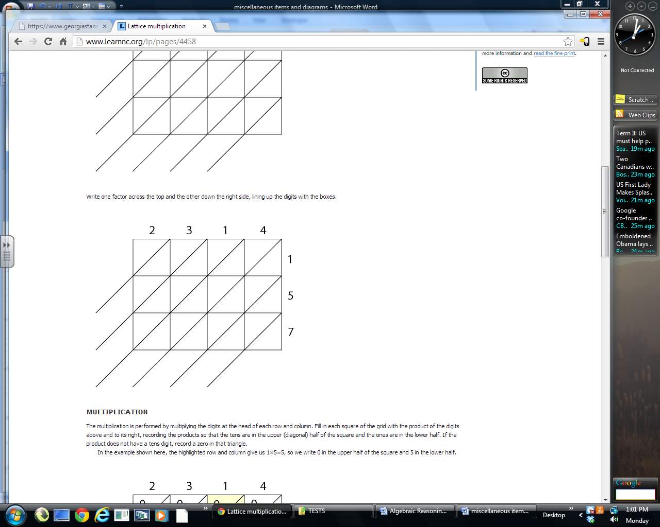 |  | - 5  - 3  - 6  - 4  - None of the above
135. Which table of values is graphed?
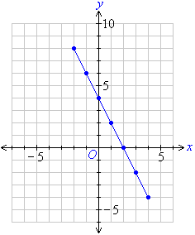 | A. | B.
  x | y
  8 | -2
  6 | -1
  4 | 0
  0 | 2
  x | y
  -3 | 7
  -1 | 5
  1 | 2
  2 | 0
 | C. | D.  E. None of the above
  x | y
  -2 | 8
  -1 | 6
  0 | 4
  2 | 0
  x | y
  4 | -4
  3 | -2
  2 | 0
  0 | 5

136. If x is odd and y is odd, which of the following must be even?
A. x + y B. xy C. x/y D. y/x E. None of the above

137. Which point is on the graph of the equation 2x + 5y = 10?
A. (-10,0) B. (2,0) C. (0,10) D. (0,2) E. None of the above

138. Two graphs of distance vs. time are shown, one dashed and one solid.
What does the point of intersection mean?

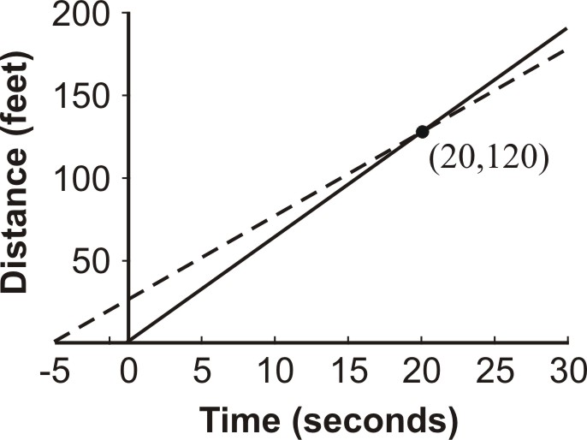
  A. In 20 minutes,
  the distance will be 120 ft. for both.
  B. In 2 hours,
  the distance is the same, 20 ft..
  C. In 120 seconds,
  the distance will be 20 ft. for both.
  D. In 20 seconds,
  the distance will be 120 ft. for both.
  E. None of the above
139. The table of values show the height of a young boy at different ages. Which equation would give you his height at age 11 if the pattern would continue?

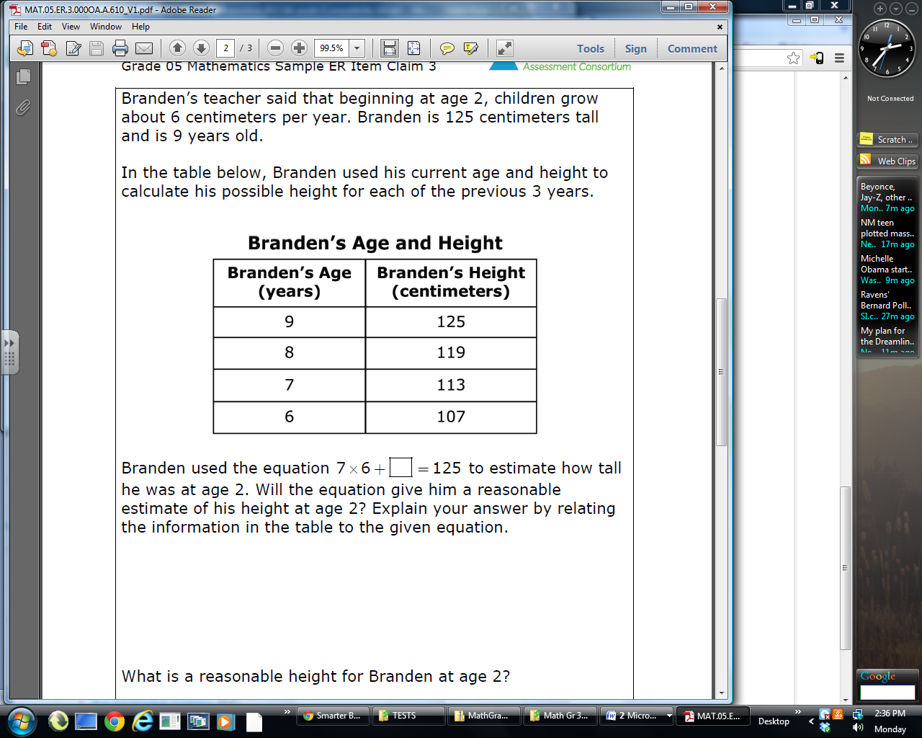

A. (9 x 6) + 125 B. (11 x 6) + 107 C. (11 x 6) + 71
D. (6 x 2) + 107 E. None of the above

140. Which expression could NOT be used to figure the total cost at a restaurant if 15% tip is given to the waiter? Let C = Cost of the meal

A. 0.15C + C B. C/10 + ½(C/10) + C C. 1.15C
D. C + 15 E. All are correct.

Shade the correct answer! Name______________________
Example: A B C D E
School _____________________

101. A B C D E | 121. A B C D E
102. A B C D E | 122. A B C D E
103. A B C D E | 123. A B C D E
104. A B C D E | 124. A B C D E
105. A B C D E | 125. A B C D E
106. A B C D E | 126. A B C D E
107. A B C D E | 127. A B C D E
108. A B C D E | 128. A B C D E
109. A B C D E | 129. A B C D E
110. A B C D E | 130. A B C D E
111. A B C D E | 131. A B C D E
112. A B C D E | 132. A B C D E
113. A B C D E | 133. A B C D E
114. A B C D E | 134. A B C D E
115. A B C D E | 135. A B C D E
116. A B C D E | 136. A B C D E
117. A B C D E | 137. A B C D E
118. A B C D E | 138. A B C D E
119. A B C D E | 139. A B C D E
120. A B C D E | 140. A B C D E

Shade the correct answer! Name______________________
Example: A B C D E
School _____________________
ANSWER KEY

101. A B C D E | 121. A B C D E
102. A B C D E | 122. A B C D E
103. A B C D E | 123. A B C D E
104. A B C D E | 124. A B C D E
105. A B C D E | 125. A B C D E
106. A B C D E | 126. A B C D E
107. A B C D E | 127. A B C D E
108. A B C D E | 128. A B C D E
109. A B C D E | 129. A B C D E
110. A B C D E | 130. A B C D E
111. A B C D E | 131. A B C D E
112. A B C D E | 132. A B C D E
113. A B C D E | 133. A B C D E
114. A B C D E | 134. A B C D E
115. A B C D E | 135. A B C D E
116. A B C D E | 136. A B C D E
117. A B C D E | 137. A B C D E
118. A B C D E | 138. A B C D E
119. A B C D E | 139. A B C D E
120. A B C D E | 140. A B C D E

