Kansas City Area Teachers of Mathematics
2013 KCATM Math Competition

ALGEBRAIC REASONING AND DATA
GRADE 4

INSTRUCTIONS

• Do not open this booklet until instructed to do so.

• Time limit: 15 minutes

• You may use calculators on this test.

• Use the π key on your calculator or 3.14 as the approximation for pi.

• Mark your answer on the answer sheet by FILLING in the CIRCLE.

• You may not use rulers, protractors, or other measurement devices on this test.

(Some of the questions on this exam were adapted from the NCTM website and other resources available on state websites to help prepare for the CCSS.)

Student Name ____________________________ Student Number _______

School __________________________________
101. The gravitational pull on Mars is 0.377 of Earth’s gravitational pull. If you weigh 85 pounds (lbs) on Earth, what would you weigh on Mars?
- 225.5lbs B. 32.0lbs C. 84.6lbs D. 22.5lbs E. None of the above
102. A farmer plants 450 seeds per row in his field. How many FULL rows would he be able to plant with 50,000 seeds?
A. 111 B. 125 C. 500 D. 150 E. None of the above
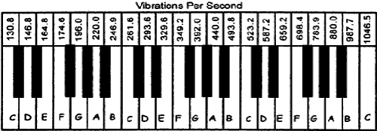
103. Find the A notes on the piano keyboard. Find a pattern for the vibrations for the A notes. IF the keyboard would be extended, how many vibrations per second would be produced when the fourth A note is played?

A. 220 B. 880 C. 1760 D. 1320 E. None of the above
(NCTM: Adapted from Everyday Mathematics Sixth Grade Resource Book, from the University of Chicago School Mathematics Project [Chicago, Ill.: Everyday Learning Co., 1999].)

104. If Juan spent ¼ of his money on a game that costs $20, how much did Juan have originally to spend? Use the diagram below to reason the answer.
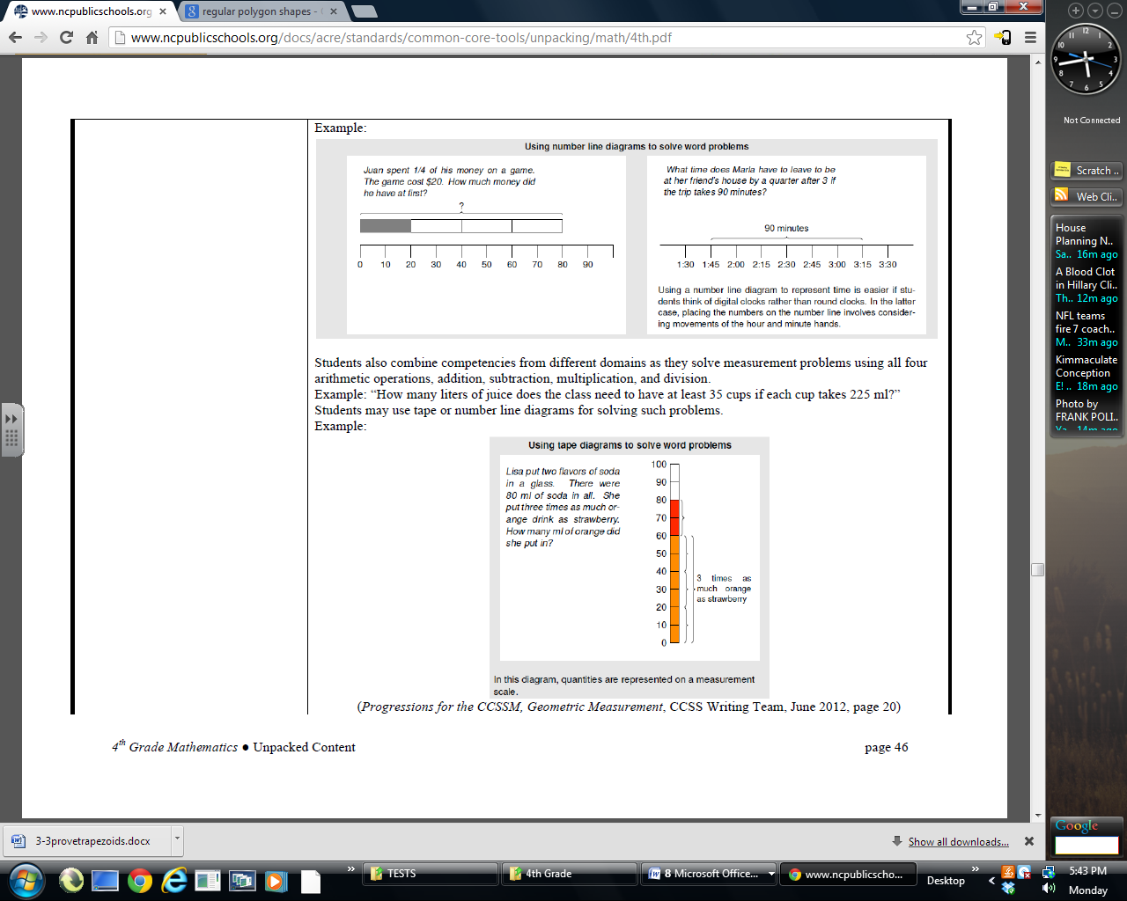
- $40 B. $60 C. $80 D. $100 E. None of the above
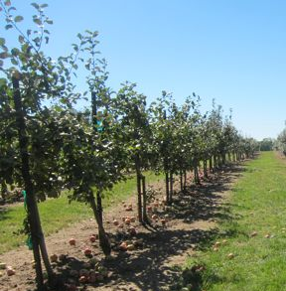
105. How many apples would you get from the 10th tree if an apple farmer notices a pattern from picking the apples on the 1st through the 3rd tree. He picked 4 from the first tree, 7 from the second tree, and 10 from the third tree.
Tree | 1 | 2 | 3 | 4 | 5 | 6 | 7 | 8 | 9 | 10
Apples | 4

- 32 B. 34 C. 28 D. 37 E. None of the above
106. What time does Alexandria have to leave her house to arrive at her friend’s house by a quarter after 3 if the trip takes 90 minutes? Use the number line to help you.

A. 1:30 B. 1:45 C. 2:00 D. 2:15 E. None of the above

107. George has been the name of three of our presidents. The most popular presidential name has been James (6 presidents). John and William tie (each had 4). Franklin was the name of 2 presidents. Complete the table of data.

Name | George | James | John | William | Franklin
# of Presidents

Use this information to find the fraction representing presidents whose first name was James, Franklin, William, George, or John. President Barack Obama is the 44th president.
- $\frac{2}{\text{11}}$ B. $\frac{7}{\text{22}}$ C. $\frac{\text{15}}{\text{44}}$ D. $\frac{\text{19}}{\text{44}}$ E. None of the above

108. Mathematician Sophie Germain worked with codes and mathematics. If each letter of the alphabet is assigned a number starting with A = 1, B = 2, etc., the values of the letters in the alphabet will start to look like this:
A | B | C | D | E | F | G | H | I | J | K | L | M | N | O | P | Q | R | S | T | U | V | W | X | Y | Z
1 | 2 | 3 | 4

If your code is sum of the letter values, what is the value of “MATH”?
- 34 B. 42 C. 31 D. 38 E. None of the above

109. Scientists use the distance between each fossil footprint to estimate how fast dinosaurs moved. About how far could Tyrannosaurus Rex run in 30 minutes if scientists estimate that T. Rex could run about 25 miles per hour?

- 30 mi. B. 15 mi. C. 12.5 mi. D. 50 mi. E. None of the above
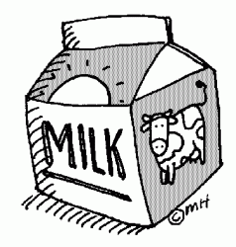
110. Exactly $25 was collected at lunch which included the meal and milk. Each meal costs $0.90 and a carton of milk costs $0.25. If 28 milk containers were sold, which equation could be used to solve for the number of “n” lunches that were sold?
- 0.90n + 0.25 x 28 = 25 B. 0.90 x 28 + 0.25x = 25
C. 1.15n = 25 D. (0.90n + 0.25) x 28 = 25 E. None of the above
111. It takes Abby twice as long as Blair and half as long as Caitlin to ride her bike to school. If it takes Blair 10 minutes to ride her bike to school, how long does it take Caitlin to get to school?

A. 5 min. B. 20 min. C. 40 min. D. 25 min. E. None of the above

112. What are the next three numbers in the pattern:
64, 32, 16, 8, 4, ___, ___, ___
A. $2,1,\frac{1}{2}$ B. $2,\frac{1}{2},\frac{1}{4}$ C. 3, 2, 1 D. 2, 1, ¼ E. None of the above

113. What is the next number in the pattern: 15, 13, 17, 15, 19, ___
A. 17 B. 21 C. 23 D. 24 E. None of the above

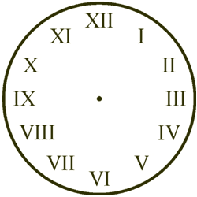
114. Roman numerals are still used today. We see them on some clock faces or as page numbers. If I = 1, V = 5, and
X = 10 which Roman Numeral is the number “nine”?

- IXI B. XII C. IX D. XIV E. None of the above

115. Bedtime is a problem for the goofy sheep in Six Sleepy Sheep (Gordon 1991). How many different ways could you line up 3 sheep on the bed?

A. 2 B. 3 C. 4 D. 6 E. None of the above

116. Lewis and Clark took about two and a half years to cover 8000 miles. If you make the 8,000 mile trip, about how much would it cost at today's prices of $3.00 per gallon of gas when your car gets 25 miles per gallon (mpg)?

- $960 B. $2667 C. $320 D. $66,667 E. None of the above

117. What are the missing numbers in the pattern: 2310, 2320, __, __, 2350
- 2330, 2360 B. 2330, 2340 C. 2330, 2370
D. 2340, 2360 E. None of the above

118. The 112 fourth-grade students at Edgemont School donate pennies to raise $75 for a local charity. What is the minimum number of pennies each student needs to bring if they are to meet their goal of collecting $75?

- 75 pennies B. 67 pennies
C. 100 pennies D. 82 pennies E. None of the above
119. On October 14, 2012, Felix Baumgartner skydived from 39,045 meters in a little over 9 minutes traveling a maximum speed of 834 miles per hour. How do you change his distance of 39,045 meters into kilometers?
- 39,045 divided by 10 B. 39,045 divided by 100
- 39,045 divided by 1000 D. Multiply 39,045 by 1000
E. None of the above
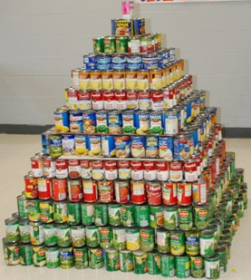
120. Your school is having a canned food drive for Harvesters. How many total cans would you have if you made a solid pyramid with 15x15 cans on the first level, 14x14 on the second level and continue the pattern all the way up to just one can on top?
- 1240 B. 980
C. 1000 D. 1310 E. None of the above

121. Which of the following numbers is prime?
A. 15 B. 29 C. 51 D. 133 E. None of the above

122. What is the value of the following expression: 3 x (3 + 7) ÷ 2
A. 15 B. 8 C. 31.5 D. 19.5 E. None of the above

123. If n² = n x n, and n³ = n x n x n, what is the value of 2⁵?
A. 10 B. 8 C. 16 D. 32 E. None of the above

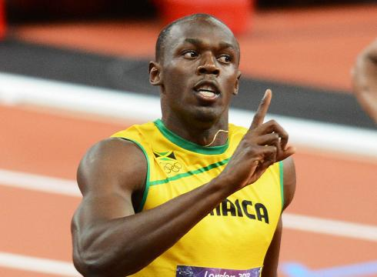

124. In the 2012 Summer Olympics in London, Usain Bolt won the 100 meters dash in 9.63 seconds. Michael Phelps, who won a record number of medals at 18, swam the 100 meter butterfly in 51.21 seconds. How much faster can the Usain run 100 m compared to the Michael Phelps swim 100m?

A. 41.58sec. B. 60.84sec. C. 5.32sec. D. 32.44sec. E. None of the above
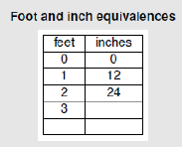
125. Use the table of values to help you find the value of 9 feet in inches.

- 36 B. 96 C. 108 D. 72 E. None of the above

126. Mrs. Hiatt (H) is one year less than twice as old as her son, Jaime (J). Which equation represents this numerical relationship?
- 2H – 1 = J B. 2J – 1 = H
C. 2J + 1 = H D. 2H + 1 = J E. None of the above
127. The chart below shows the average height for boys and girls from ages six to twenty. At what age does growth stop for each group?
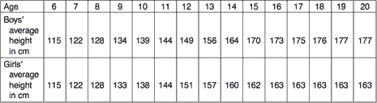

- Boys: 20; Girls: 16 B. Boys: 19; Girls: 16
C. Boys: 15; Girls: 15 D. Boys: 17; Girls: 17 E. None of the above

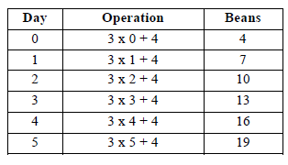
128. Examine the operation of how to use the number of days to find the number of beans in a classroom jar. On Day 31, how many beans would be in the jar?

- 94 B. 100 C. 97 D. 159
E. None of the above

129. Which sign would be correct when comparing the following numbers:
4,512 ___ 4,511
A. < B. = C. > D. < E. None of the above

130. Compare the numbers: three fifteenths ___ three tenths
A. < B. = C. > D. > E. None of the above

131. Which shape below has a perimeter with the value as: (4 x 2) + (2 x 2)?
A
B
C
D
E. None of the above

132. Which number is “seven less than twice twelve”?
A. 14 B. 17 C. 16 D. 15 E. None of the above

133. Which number is “nine more than half seventy-four”?
A. 37 B. 45 C. 46 D. 41 E. None of the above

134. Which is the correct expression for “eighteen less than a number”?
A. 8 - n B. n - 8 C. 18 - n D. n – 18 E. None of the above

135. Find the value for the expression: 12/4 + (15 – 4) x 2
A. 28 B. 25 C. 41 D. 32 E. None of the above

136. Which statement shows the commutative property of multiplication?
A. 5 x (3 x 7) = (5 x 3) x 7 B. (5 + 3) + 7 = 5 + (3 + 7)
C. 5 x (3 x 7) = 5 x (7 x 3) D. 5(3 + 7) = (5 x 3) + (5 x 7)
E. None of the above

137. Which statement shows the associative property of addition?
A. 9 + (6 + 3) = (9 + 6) + 3 B. 9 + (6 + 3) = 9 + (3 + 6)
C. 9 + 6 = 6 + 9 D. 6 x (2 x 7) = (6 x 2) x 7
E. None of the above

138. Which one is the distributive property showing the product of 8 x 12 ?
A. 8 + 12 x 8 + 2 B. 8 x 10 + 8 x 2 C. 12(4) + 12(2)
D. 10 x 8 + 10 x 2 E. None of the above

139. An ice cream sundae stand at the state fair offers the choice of toppings on each sundae. The toppings available are chocolate syrup, caramel, chocolate chips, and sprinkles. How many different combinations of two toppings can you make?

- 2 B. 3 C. 4 D. 5 E. None of the above

140. If your parents give you one penny on Day 1, 2 pennies on Day 2, 4 pennies on Day 3, and 8 pennies on Day 4. If the pattern continues, how many pennies will your parents give you on Day 15?
Day | 1 | 2 | 3 | 4 | 5 | 6 | 7 | 8 | 9 | 1 | 11 | 12 | 13 | 14 | 15
#Pennies | 1 | 2 | 4 | 8 |  |  |  |  |  |  |  |  |  |  | ?

- 30 B. 8,192 C. 16,384 D. 32,768 E. None of the above

Shade the correct answer! Name______________________
Example: A B C D E
School _____________________

101. A B C D E | 121. A B C D E
102. A B C D E | 122. A B C D E
103. A B C D E | 123. A B C D E
104. A B C D E | 124. A B C D E
105. A B C D E | 125. A B C D E
106. A B C D E | 126. A B C D E
107. A B C D E | 127. A B C D E
108. A B C D E | 128. A B C D E
109. A B C D E | 129. A B C D E
110. A B C D E | 130. A B C D E
111. A B C D E | 131. A B C D E
112. A B C D E | 132. A B C D E
113. A B C D E | 133. A B C D E
114. A B C D E | 134. A B C D E
115. A B C D E | 135. A B C D E
116. A B C D E | 136. A B C D E
117. A B C D E | 137. A B C D E
118. A B C D E | 138. A B C D E
119. A B C D E | 139. A B C D E
120. A B C D E | 140. A B C D E

Shade the correct answer! Name______________________
Example: A B C D E
School _____________________
ANSWER KEY

101. A B C D E | 121. A B C D E
102. A B C D E | 122. A B C D E
103. A B C D E | 123. A B C D E
104. A B C D E | 124. A B C D E
105. A B C D E | 125. A B C D E
106. A B C D E | 126. A B C D E
107. A B C D E | 127. A B C D E
108. A B C D E | 128. A B C D E
109. A B C D E | 129. A B C D E
110. A B C D E | 130. A B C D E
111. A B C D E | 131. A B C D E
112. A B C D E | 132. A B C D E
113. A B C D E | 133. A B C D E
114. A B C D E | 134. A B C D E
115. A B C D E | 135. A B C D E
116. A B C D E | 136. A B C D E
117. A B C D E | 137. A B C D E
118. A B C D E | 138. A B C D E
119. A B C D E | 139. A B C D E
120. A B C D E | 140. A B C D E

